FST Name:
1.1 Comparative Statistics Notes Date: Block:
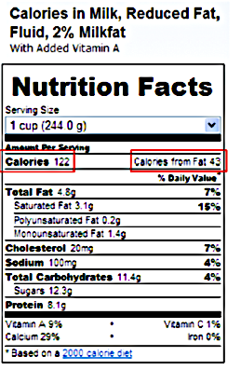
Think about this: What does it really mean when you buy 2% milk?

Fat from calories?

Fat in grams?

Calories from fat for a 2000 calorie diet?

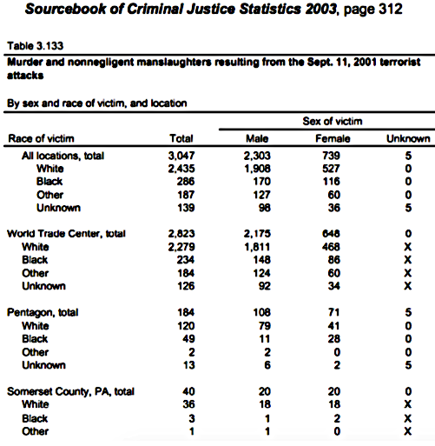

1. What percent of those killed in the September
11th terrorist attacks were killed in the
World Trade Center?

2. What percent of those killed in September
11th terrorist attacks that were killed at the
Pentagon were women?

3. What percent of those killed in the
September 11th terrorist attacks were listed
as black?

Remember statistics can be ____________________ depending on how we want the data to look.

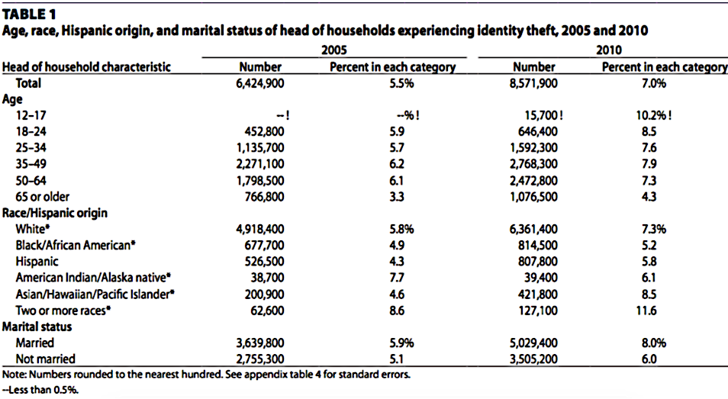

There are three types of comparative statistics that are used to report data:

1. ____________________________ 2. __________________________ 3. ________________________

What percent of homes experienced identity theft in 2005?

What percent of homes experienced identity theft in 2010?

Type of Comparative Statistic | Formula | Work & Meaning
Subtraction
Division
Percent Change
Which statistic would you use if you were trying to make the argument that identity theft is a growing problem in the United States and everybody should be very concerned?

Which statistic would you use if you were trying to make the argument that identity theft is growing, but not that quickly and it’s not a major concern in the United States?

Write a sentence (as if it were to appear in a newspaper article) arguing each side of the argument.
Identity theft is a huge problem:

Identity theft is not a big problem:

