FST Name:
1.2 Dot plots & Stem & Leaf plots Notes Date: Block:

Dot Plots
Allows us to…

Dot Plot of Minutes Late to work…
What does this column represent?

The range is defined as… ___________________________________________________________________

The mode of the data is defined as ___________________________________________________________

Range of data for minutes late to work | Mode of the late to work data set

Shape – skewed distributions ( _______________________________ )

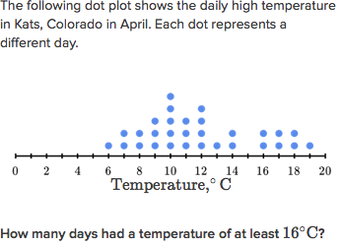
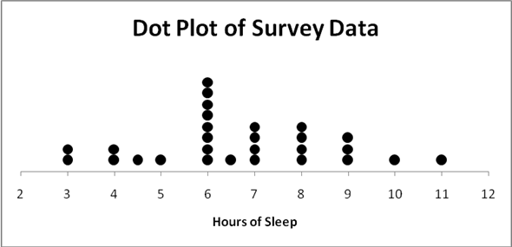

What is the range of the data?

What is the mode of the data? Describe what it means. How many days had a temperature below
at least 11^{O} C?

Stem and Leaf Plots
NOTE:
Construct a stem and leaf plot for the number of text -
Messages sent by members of the junior class at PG.

Text Messages Sent Stem & Leaf Plot

*If you rotate a stem and leaf diagram 90 degrees
counterclockwise, a _________________ is created

What is the range of the text message data?

What is the median of the data?

