FST Name:
1.3 Notes Date: Block:

1.3: Sigma Notation and Measures of Center

Sigma Notation  $$\sum_{i=1}^{n}{x_{i}}=$$ | Example:  $$\sum_{k=1}^{4}{2k+3}=$$
Practice.
1. Consider a set of x-values: x₁ = 14, x₂ = 16, x₃ = 15, x₄ = 18, x₅ = 17 2. Evaluate.
$$\sum_{i=1}^{5}{x_{i}}=$$

Mean  Also written as  ______ | Definition:  Mean is the _____________________________ measure of center.  How to find it?

It is convenient to use sigma notation to define the mean of a set of data.
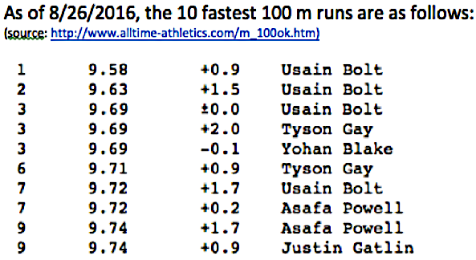
1. Express the mean of the fastest 100m runs in sigma notation
and solve.

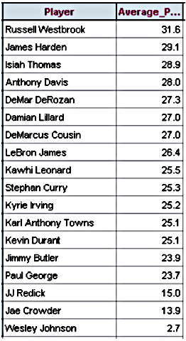

2. The following data points represent the NBA players average
number of points scored per 48 minutes of play in the 2016-2017
regular season. http://www.espn.com/nba/statistics/player/_/stat
/scoring-per-game/sort/avgPoints/count/241

The mean is affected by ___________________.
Outliers | Definition:
Examples: Calculate the mean of the two data sets.
1.) 1, 2, 5, 6, 7, 9, 100 2.) 1, 2, 5, 6, 7, 9

Which mean is a better measure of center?

Median | Definition:  ________________ most common measure of center.  Data must be in ___________________ or _____________________ order.
Examples:
Calculate the median of the data set of NBA players.

If you have an even amount of data, you will have to calculate the
___________________ of the middle two numbers.

Mean of NBA players: Median of NBA players:

Practice.
1. The weekly salaries of six employees at McDonalds are $140, $220, $90, $180, $140, $200.
For these six salaries, find a) the mean, b) the median, and c) the mode.

2.

