FST Name:
1.4 Notes Date: Block:

1.4: Boxplots, 5 Number Summary, and Outliers
Consider the data below.
70, 70, 73, 73, 74, 75, 77, 77, 79, 79, 80, 81, 82, 82, 82, 82, 82, 83, 83, 83, 83, 84, 84, 85, 88, 90, 91, 92, 97, 100

Min: ________ Max: _________ Mean: ___________ Median: _______________

Five Number Summary:
1.
2.
3.
4.
5.

First Quartile: | Third Quartile:

BOXPLOT (BOX AND WHISKER PLOT)

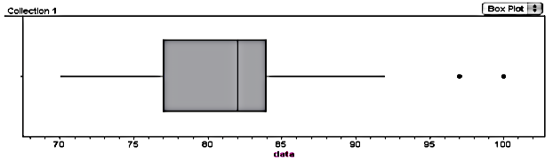

The IQR ( _______________________________) is defined to be IQR = Q3 – Q1.

Find the IQR for the data above.

TO FIND OUTLIERS:
Upper Outliers | Lower Outliers
Example: | Example:

“Analyze the Data”
1. Shape
2. Five Number Summary
3. Mean and Standard Deviation
4. Outliers (using IQR)
Practice.
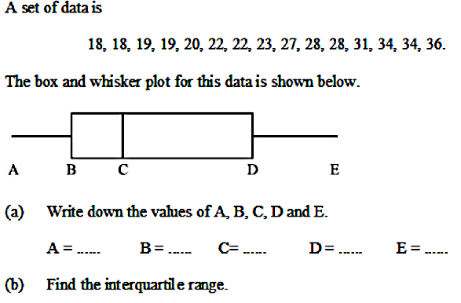
1.

(c). Find the upper and lower cutoff for outliers.

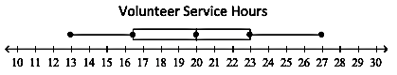
2. The box and whisker plot shows the volunteer service hours performed by students at Porter-Gaud Upper School last summer.

What is the five number summer of this data set?

What percentage of data is between the lower quartile and the upper quartile?

