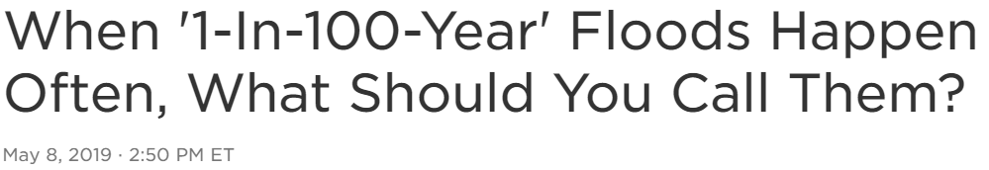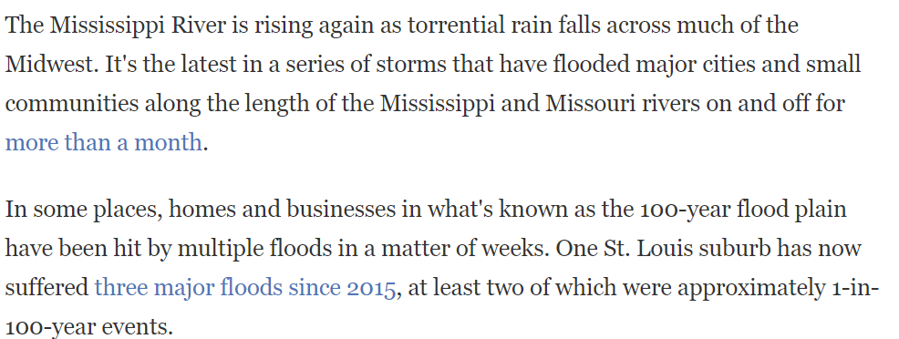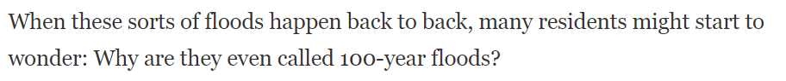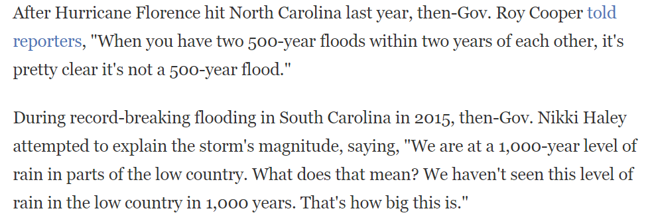

<https://www.npr.org/2019/05/08/720737285/when-1-in-100-year-floods-happen-often-what-should-you-call-them>