FST Name:
2.2 Notes Date: Block:

Chapter 2.2: Curve Fitting with Linear and Quadratic Functions

Point Slope Form | Transformation of a Linear Function

1. What does “a” represent? 2. What do the “h” and “k” represent?

Example) Write the linear model for the graph below.
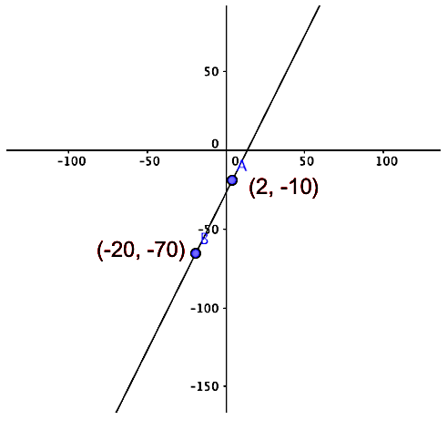

Example) Open up the CODAP file titled Linear Modeling Activity and follow the directions. Go through the process three times. Record the NewDataSet number you choose and the Noise number you choose.

NewDataSet Number: | NewDataSet Number: | NewDataSet Number:
Noise Number: | Noise Number: | Noise Number:
a: | a: | a:
h: | h: | h:
k: | k: | k:
Final Model: | Final Model: | Final Model:

Vertex Form of a Quadratics | Transformation of a Quadratic Function
1. What does “a” represent? 2. What do the “h” and “k” represent?

Write a quadratic model for the graph below.
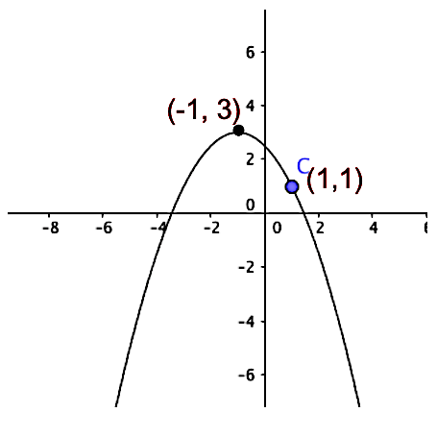

Example) Open up the CODAP file titled Quadratic Modeling Activity and follow the directions. Go through the process three times. Record the NewDataSet number you choose and the Noise number you choose.

NewDataSet Number: | NewDataSet Number: | NewDataSet Number:
Noise Number: | Noise Number: | Noise Number:
a: | a: | a:
h: | h: | h:
k: | k: | k:
Final Model: | Final Model: | Final Model:

Example) The scatter plot represents the total number of bacteria growing in a petri dish starting at 1:00PM.

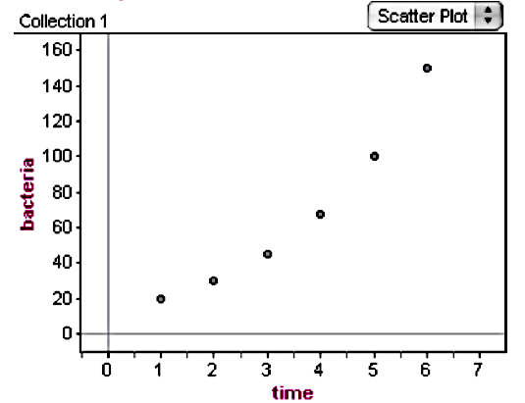
1. Write a quadratic model for the data.

2. How many bacteria will be in the dish at 3:00am?
(use your model from part a)

3. At what time will there be 200 bacteria in the dish?

Example) Open a blank CODAP file and insert the data below to see if there is a relationship between total fat grams in each sandwich and total calories.
a) Is a linear or quadratic function a better fit?

b) Create a model for this data.

c) Estimate how many calories would be in a sandwich
that contained 40 grams of fat?

d) Estimate how much grams of fat would be in a
sandwich that contained 1000 calories?

