FST Name:
2.3-4 Practice: Analyzing Bivariate Data Practice Date: Block:

2.3 – 4: Analyzing Bivariate Data Practice

Example 1) When a honeybee finds a source of food, it returns to the beehive and communicates to the other bees the direction and distance of the source. The bee makes a loop, and waggles its belly along a line which gives the approximate direction of the food source. It then repeats this process several times. The time for each cycle (one loop and one waggle) reveals the approximate distance of the food source. The table below shows cycle times and the distance of the source for that cycle.
Cycle Time (in seconds) | 3.5 | 3.8 | 3.9 | 4.4 | 4.3 | 5 | 5.1 | 5.6 | 6 | 7 | 7.6
Distance (in meters) | 1.35 | 1.5 | 1.5 | 2 | 2.15 | 2.65 | 2.75 | 3.5 | 4 | 5 | 6

Create a model using the Cycle Time as the independent variable and Distance as the dependent variable.

Analyze the Data:

A bee has a cycle time of 8.9 seconds. Approximately how far is the distance to the food?

A bee travels 14 meters to a food source. Approximately how long was it’s cycle time when it was talking to the other bees in the hive?

Example 2) The table gives the number of fatal crashes per 100 million miles driven for various age groups. The idea for this data set comes from Blizer, Algebra 2,page 168 Also see:
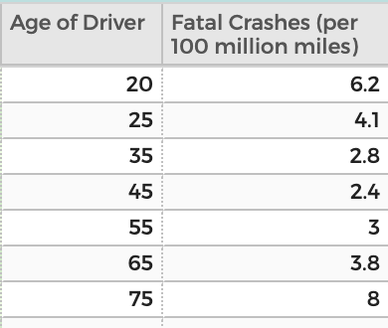
Driver Age and Crash Involvement, Williams and Carstens, https://ajph.aphapublications.org/doi/pdf/10.2105/AJPH.79.3.326, 11/3/2018 2. Driver Behavior, AAA, http://aaafoundation.org/rates-motor-vehicle-crashes-injuries-deaths-relation-driver-age-united-states-2014-2015/, 11/3/2018

Create a model using the Age of Driver as the independent variable and Fatal Crashes (per 100 million miles driven) as the dependent variable.

Analyze the Data:

According to your model, who are the safest drivers? How many fatal crashes are being caused per 100 million miles driven for the safest drivers?

What are the approximate ages of those who are causing 5 fatal crashes per 100 million miles driven?

