FST Name:
2.3 Notes Date: Block:

Chapter 2.3: Analyzing Bivariate Data using Linear and Quadratic Models

Warm Up: Write a linear model for the scatter plot below.

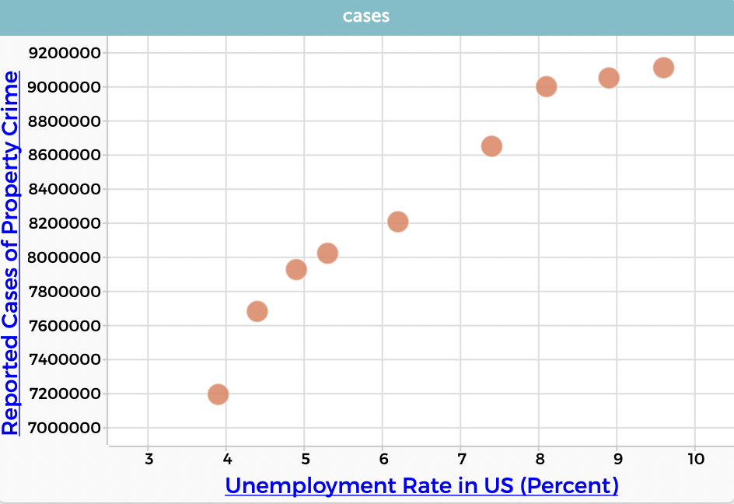

When do you know a model is appropriate? How good is it?
1. 2. 3.

Open up the CODAP file titled Unemployment and Crime. We are going to learn how to create a linear model in CODAP. Write the steps we use in the space below.

Linear Model using CODAP:

After you decide on what type of model to use and fit a curve to the data, you analyze the ________________

Residual in statistics is the same as _______________________.

Residual = __________________ – __________________

Now we are going to make a residual plot in CODAP. Write the steps we use in the space below.

Residual plot for Gas Mileage Model
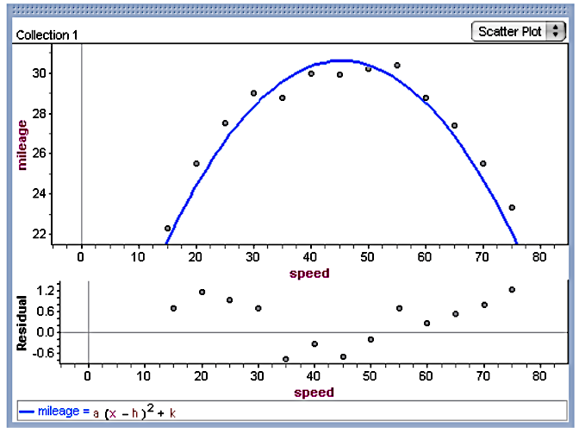

Example 1)
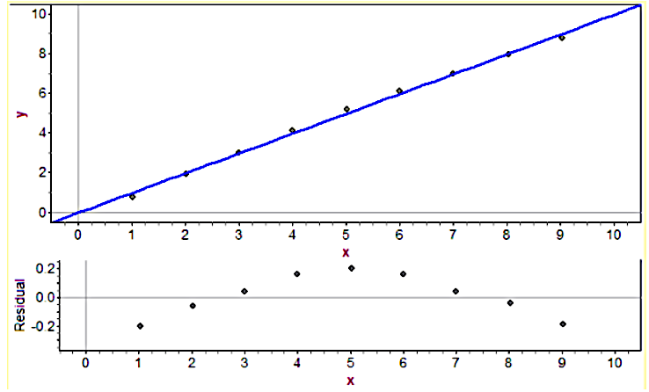
Pattern:

Magnitude:

Conclusion:

Example 2)
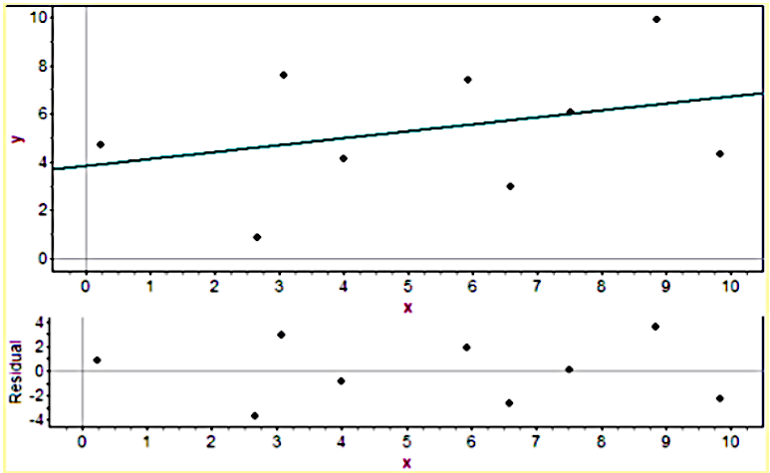

Pattern:

Magnitude:

Conclusion:

Example 3)
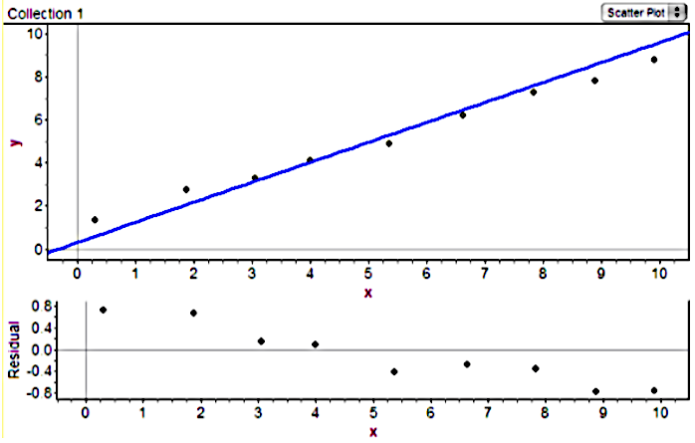

Pattern:

Magnitude:

Conclusion:

Example 4)

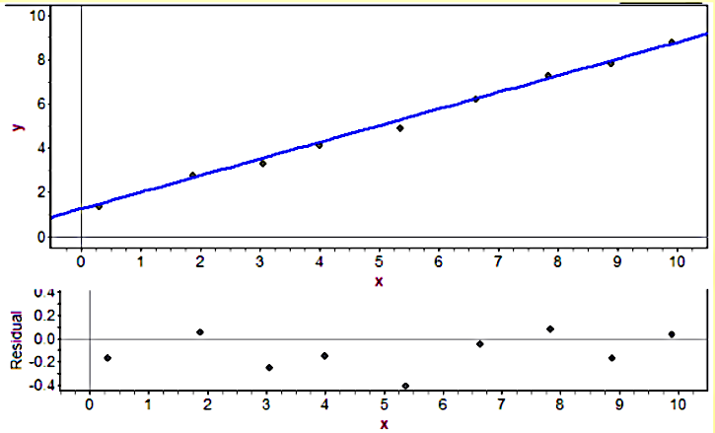

Pattern:

Magnitude:

Conclusion:

Example 5)

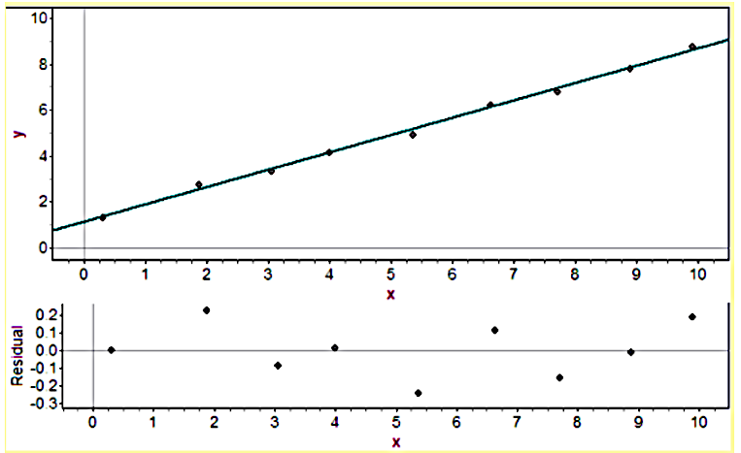
Pattern:

Magnitude:

Conclusion:

Analyzing Bi-Variate Data

1. Create a ______________ for the bivariate data.

2. Analyze _________________.
- Adjust model as needed.

3. Appropriateness of Model. (Why model is appropriate or why it is not appropriate)

4. How good of a ______________ will the model be? Why?

Go back to your linear model that you made for the Unemployment and Crime data. Adjust the model so that your model is appropriate if you can. Write your new linear model in the space below and analyze the bi-variate data.

New Linear Model using CODAP:

Analysis of Model (address appropriateness of model and accuracy of model):

