***Lesson 2.6: Toolkit Functions with Transformations***

<https://fluidmath.net/apps/FluidMath/?d=E6A34CFEA75&n=ti1>

Click the website above and follow the instructions. Fill in the guided notes as you go through each exercise.

**Part 1: Five Functions**

Before you get started, what is the definition of a function?

**Function -**

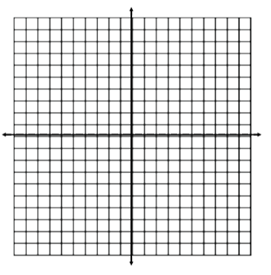1. The Quadratic Function 

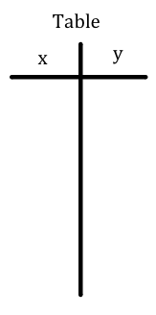

Based on the graph above and your knowledge of transformations, how do you think the graph of the function y = (x – 5)2 + 2 compares to the parent function y = x2? What about y = -x2?

The quadratic function is concave up. What do you think the quadratic function y = -x2 is called?

Where is the function y = x2 increasing? Decreasing?

2. The Square Root Function 

Why do you think the function is undefined for all negative values of x?

At what x value will the y value reach 9?

How would the graph of the function compare to the graph of the parent function?

3. The Absolute Value Function

Based on the parent function’s graph above, how do you think the graph of y = -|x| looks? What about the graph of y = |-x|?

Where is the function increasing? Decreasing?

Does the absolute value function have an absolute minimum or an absolute maximum?

4. The Reciprocal Function 



Why is the function not defined when x = 0? What is happening at the vertical line x = 0?

What is happening at the horizontal line y = 0? Is there ever an x value that can be plugged in to return a y value of 0?

Where is the reciprocal function concave up? Concave down?

Where is the reciprocal function increasing? Decreasing?

How would the graph of the function  compare to the graph of the parent function?

5. 

What changed from the graph of the function  to ? Does  still have a vertical asymptote at x = 0?

What is happening at the horizontal line y = 0? Is there ever an x value that can be plugged in to return a y value of 0?

Where is the reciprocal function concave up? Concave down?

Where is the reciprocal function increasing? Decreasing?