FST Name:
2.8 Least Squares Regression Lines Date: Block:

The data in the table below shows the number E (in thousands) of employees in the cellular communications industry in the US from 2002 to 2007.

Year | Employees (thousands)
2002 | 192
2003 | 206
2004 | 226
2005 | 233
2006 | 254
2007 | 267

Line of Best Fit
*Fitting a linear models to best represent the relationship described by a scatter plot.
* You can do this by finding the equation that passes through two points.

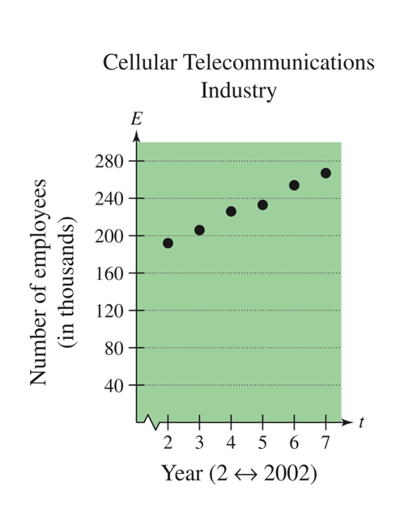
Ex. 1 Find a linear model that relates the year to the number of employees in the cellular industry in the US.

***Note*** Once you have found a model, you can determine how well it fits by comparing the actual values with the values given by the model.
t | 2 | 3 | 4 | 5 | 6 | 7
Actual  E | 192 | 206 | 226 | 233 | 254 | 267
Model
E

Residual

*_____________________________________________________________________________

*

Least Squared Regression (Linear Regression)

https://www.youtube.com/watch?v=jEEJNz0RK4Q

*_____________________________________________________________________________

*_____________________________________________________________________________

*_____________________________________________________________________________

Correlation Coefficient
* When you use a regression feature, you may get an r-value.
* This is called the correlation coefficient.
* ____________________________________________________________________________

*_____________________________________________________________________

* ____________________________________________________________________________
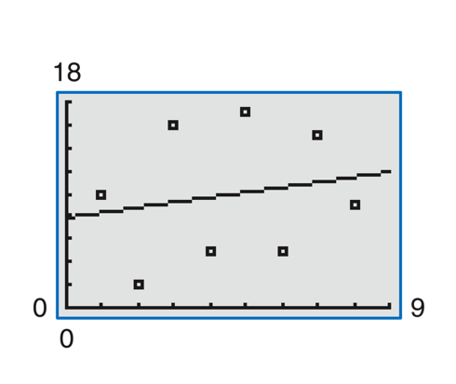
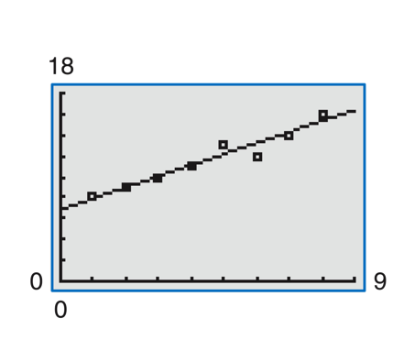

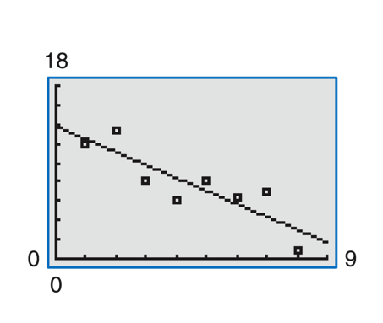
Ex. 2 What do you think r is?

Ex. 3 Open the CODAP file Manatee Deaths and analyze the data using motorboat registrations as the independent variable and deaths as the dependent variable.

Model:

Analysis:

Steps to calculating r² in CODAP

