FST Name:
Notes 3.1 Date: Block:

3.1: Triangles Review

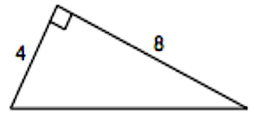
Pythagorean Theorem Do the following lengths form Find the missing side of each triangle.
a right triangle? 1.
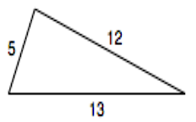
1.
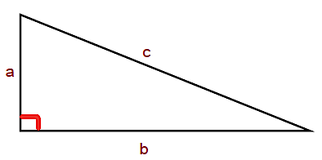

2.

Special Right Triangles Find the missing sides of the triangles using
30º - 60º - 90º 45º – 45º – 90º special right triangles.
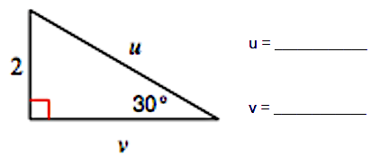
1.

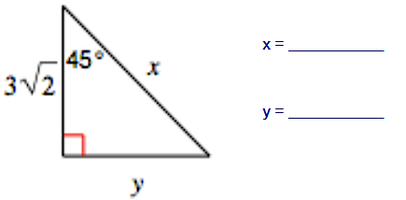
2. 3. 4.
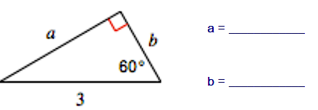

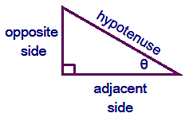
Trigonometry
$\sin{θ=}$ $\cos{θ=}$ $\tan{θ=}$

$\csc{θ=}$ $\sec{θ=}$ $\cot{θ=}$

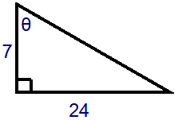
1. 2. In a right triangle, $θ$ is an acute 3. If $θ$ is an acute angle in a right
And $\cos{θ=\frac{7}{10}. }$ What is $\sin{θ?}$ triangle and $\cos{θ=\frac{3}{8}, }$ find the
other trig functions.

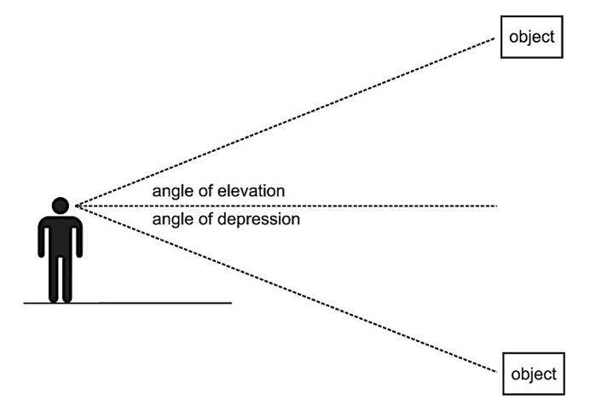
Angle of Elevation
Angle of Depression

Example) Angle of Elevation: A surveyor is standing 50 feet from the base of a large tree. The surveyor measures the angle of elevation to the top of the tree as 71.5º. How tall is the tree?

Example) Angle of Depression: A salvage ship’s sonar locates wreckage at a 12º angle of depression. A diver is lowered 40 meters to the ocean floor. How far does the diver need to walk along the ocean floor to the wreckage?

Practice: According to a Chinese legend from the Han dynasty (206 B.C.E – 200 C. E.), General Han Xin flew a kite over the palace of his enemy to determine the distance between his troops and the palace. If the general let out 800 meters of string and the kite was flying at an angle of elevation of 35º, how far away was the palace from General Han Xin’s position?

Practice: The angle of depression from the top of a 150-meter-high cliff to a boat at sea is 7º. How much closer to the cliff must the boat move for the angle of depression to become 15º?

Practice: To approach Runway 17 of the Ponca City Municipal Airport in Oklahoma, the pilot must begin a 3º descent starting from an altitude of 2714 feet above sea level. The airport has an altitude of 1007 feet above sea level. How far must the airplane fly during its descent? (Find both the ground distance and actual distance)

Practice: A 14-foot ladder is used to scale a 13-foot wall. At what angle of elevation must the ladder be in order to reach the top of the wall?

Practice: The Pyramid of the Sun in ancient Mexican city of Teotihuacan was unearthed from 1904 – 1910. From a point on the ground 300 feet from the center of its square base, the angle of elevation to its top would have been 31º. What was the height of the pyramid?

Practice Challenge: From a plane flying due east at 265 m above sea level, the angles of depression of two ships sailing due east measure 35º and 25º. How far apart are the ships?

