FST Name:
Notes 3.3 Date: Block:

3.3: Standard Position, Conterminal, & Reference Angles

Standard Position | Definition: | 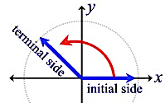

Draw an angle with the given measure in standard position.
Four Corners a) $240°$ b) $-450°$

c) $500°$ d) $-50°$ e) $95°$

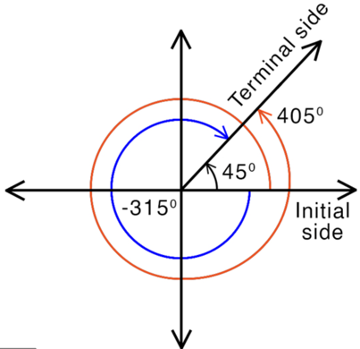

Conterminal Angles | Definition:

Sketch the angle 120º. List three angles that are conterminal with 120º.

Reference Angle Relationships
Definition:
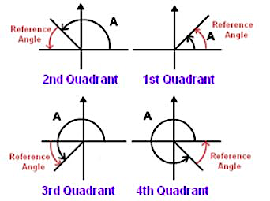

Examples: Find the reference angle for the angle given below.
a) $120°$ b) $-57°$ c) $480°$ d) $-115°$

Practice: Find the reference angle for the angle given below.
a) $260°$ b) $-650°$ c) $300°$ d) $-800°$

