FST Name:
Notes 3.4 Date: Block:

3.4 Radian Measure

Watch this video titled “What are Radians?”

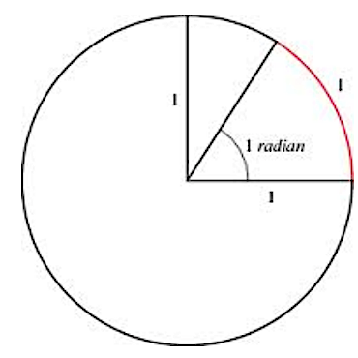
- Angles can also be measured in ___________________.

- One radian is the measure of an angle in __________________________
whose terminal side intercepts an _________ of length ______.

- Since the circumference of a circle is _________, there are _________ radians in a full circle of radius 1.
$$360°= _________ radians$$ | $$180°= _________radians$$

Converting between Degrees and Radians
Degrees to Radians | Radians to Degrees

Sketch the angle in standard position. Then convert the following degrees into radians.
a) $300°$ b) $145°$ c) $-970°$

Sketch the angles in standard position. Then convert the following radians into degrees.
a) $\frac{π}{6}$ b) $3π$ c) $-\frac{5π}{4}$

Sketch each given angle in standard position. Then find 3 angles that are coterminal (one must be negative) and the reference angle.
a) $\frac{11π}{6}$ b) $\frac{4π}{9}$

c) $-\frac{3π}{4}$ e) $\frac{2π}{3}$

