FST Name:

Notes 3.5 Date: Block:

***Lesson 3.5: The Unit Circle Part 1***

Definition of the Unit Circle:



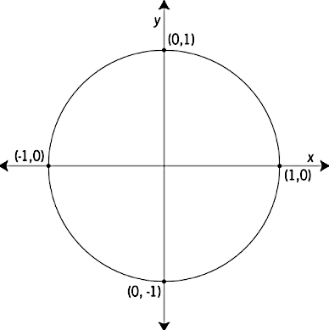Consider the angle 30o or radians in standard position.

Consider the angle 60o or radians in standard position.

Consider the angle 45o or radians in standard position.



Using special right triangles evaluate the following trigonometric expressions. What do you notice?

$a) \sin\left(\frac{π}{6}\right)=$ b) $\cos\left(\frac{π}{6}\right)=$

$c) \sin\left(\frac{π}{3}\right)=$ d) $\cos\left(\frac{π}{3}\right)=$

e) $\sin\left(\frac{π}{4}\right)=$ f) $\cos\left(\frac{π}{4}\right)=$