FST Name:
Notes 3.6 Date: Block:

Lesson 3.6: The Unit Circle Part 2

Fill in what you can from the Unit Circle.

Quadrant II Exploration Quadrant III Exploration Quadrant IV Exploration
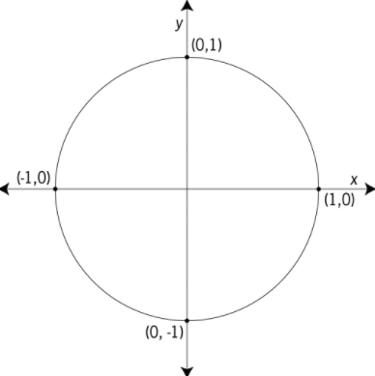

What trigonometric functions are positive in each quadrant?

Evaluating trigonometric expressions at any angle.

Example 1) Evaluate the six trigonometric functions at the angle $\frac{2π}{3}$.

$$sin\left(\frac{2π}{3}\right)= csc\left(\frac{2π}{3}\right)=$$

$$cos\left(\frac{2π}{3}\right)= sec\left(\frac{2π}{3}\right)=$$

$$tan\left(\frac{2π}{3}\right)= cot\left(\frac{2π}{3}\right)=$$

Example 2) Evaluate the six trigonometric functions at the angle $π$.

$$sin\left(π\right)= csc\left(π\right)=$$

$$cos\left(π\right)= sec\left(π\right)=$$

$$tan\left(π\right)= cot\left(π\right)=$$

Example 3) Evaluate the six trigonometric functions at the angle $-\frac{π}{4}$ .

$$sin\left(-\frac{π}{4}\right)= csc\left(-\frac{π}{4}\right)=$$

$$cos\left(-\frac{π}{4}\right)= sec\left(-\frac{π}{4}\right)=$$

$$tan\left(-\frac{π}{4}\right)= cot\left(-\frac{π}{4}\right)=$$

Example 4) Evaluate the following trigonometric expressions.
$$sin\left(-\frac{7π}{4}\right)= csc\left(-\frac{3π}{2}\right)=$$

$$cos\left(\frac{5π}{3}\right)= sec\left(\frac{5π}{6}\right)=$$

$$tan\left(\frac{7π}{6}\right)= cot\left(12π\right)=$$

