FST Name:
3.8: Graphs of Trigonometric Functions Date: Block:

1. Open the Desmos Program below. When you open the window you should see the graph of f(x) = sin(x).
https://www.desmos.com/calculator/49xsbpumus

2. In this exploration activity you will be investigating how the four sliders (a, b, c, and d) change the sine function. Notice where a, b, c, and d lie and think about what you already know about transformations.

$$f\left(x\right)=asin\left(b(x-c\right)+d$$

3. Drag the slider for a to the values listed below and describe how the graph of the function changes. Use the appropriate vocabulary and sketch the graph on the provided coordinate plane.
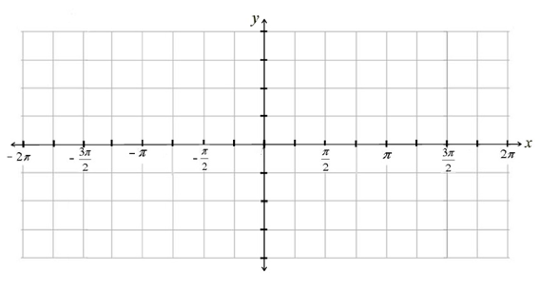
a = 2
f(x) = 2sin(x)

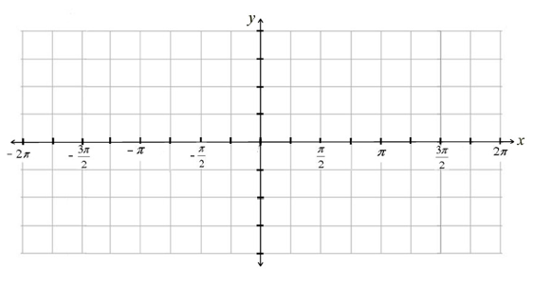
a = 3
f(x) = 3sin(x)

a = 4.5
$f\left(x\right)=\frac{9}{2}sin⁡(x)$

a = -1
f(x) = -sin(x)

Make a conjecture about what a does to the graph of sin(x). Then move a back to 1 before going to the next section.

4. Drag the slider for b to the values listed below and describe how the graph of the function changes. Specifically, how many waves occur on the interval $0≤x≤2π$? What does this change. Use the appropriate vocabulary.
b = 2
f(x)= sin(2x)

b = 3
f(x) = sin(3x)

b = 4
f(x) = sin(4x)

b = ½
$$f\left(x\right)=sin\left(\frac{x}{2}\right)$$

b = 1/4
$$f\left(x\right)=sin\left(\frac{x}{4}\right)$$

Make a conjecture about what b does to the graph of sin(x). Then move a back to 1 before going to the next section.

5. Drag the slider for c to the values listed below and describe how the graph of the function changes.
c = $π$
$$f\left(x\right)=sin⁡(x-π)$$

c = -$π$
$$f\left(x\right)=sin⁡(x+π)$$

c = $π/2$
$$f\left(x\right)=sin⁡(x-\frac{π}{2})$$

c = -2$π$
$$f\left(x\right)=sin⁡(x+2π)$$
*Does it appear that the graph changes at all?* Why?

6. Drag the slider for c back to zero, then drag the slider for d to the values listed below and describe how the graph of the function changes.
d = 1
f(x) = sin(x) + 1

d = - 4
f(x) = sin(x) – 4

Make a conjecture about what c and d do to the graph of sin(x).

7. Organize the conjectures you made in exercises 3 – 6 in the table below.

$$f\left(x\right)=asin\left(b(x-c\right)+d$$

What do you think the graphs below will look like on the interval $-2π≤x≤2π?$ Sketch the graph on the provided axes. Then use desmos to change the sliders to match the function and compare your sketch to the graph. How accurate were you? Give the characteristics of the graph in the provided spaces.
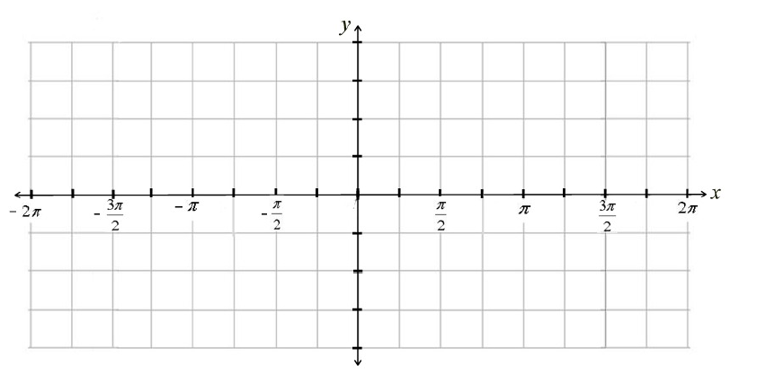
a) f(x) = 4sin(2x)

Domain:

Range:

Amplitude:

Period:

b) f(x) = -3sin(x) – 2

Domain:

Range:

Amplitude:

Period:

c) f(x) = 1.5sin(x+$π$) +1

Domain:

Range:

Amplitude:

Period:

d) f(x) = sin(3x)

Domain:

Range:

Amplitude:

Period:

x-intercepts:

8. Open the Desmos Program below. When you open the window you should see the graph of f(x) = cos(x).
https://www.desmos.com/calculator/lgo78zdzrw

9. In this exploration activity you will be investigating how the four sliders (a, b, c, and d) change the sine function.

$$f\left(x\right)=acos\left(b(x-c\right)+d$$

10. Drag the slider for a to the values listed below and describe how the graph of the function changes. Use the appropriate vocabulary.
a = 2
f(x) = 2cos(x)

a = 3
f(x) = 3cos(x)

a = 1.5
$f\left(x\right)=\frac{3}{2}cos⁡(x)$

a = -4
f(x) = -4cos(x)

Make a conjecture about what a does to the graph of cos(x). Then move a back to 1 before going to the next section.

11. Drag the slider for b to the values listed below and describe how the graph of the function changes. Specifically, how many waves occur on the interval $0≤x≤2π$? What does this change. Use the appropriate vocabulary.
b = 2
f(x)= cos(2x)

b = 3
f(x) = cos(3x)

b = 4
f(x) = cos(4x)

b = ½
$$f\left(x\right)=cos\left(\frac{x}{2}\right)$$

b = 3/4
$$f\left(x\right)=cos\left(\frac{3x}{4}\right)$$

Make a conjecture about what b does to the graph of cos(x). Then move b back to 1 before going to the next section.

12. Drag the slider for c to the values listed below and describe how the graph of the function changes.
c = $π$
$$f\left(x\right)=cos⁡(x-π)$$

c = -$\frac{3π}{2}$
$$f\left(x\right)=cos⁡(x+ \frac{3π}{2})$$

c = $π/2$
$$f\left(x\right)=cos⁡(x-\frac{π}{2})$$

c = -2$π$
$$f\left(x\right)=cos⁡(x+2π)$$
*Does it appear that the graph changes at all?* Why?

13. Drag the slider for c back to zero and then drag the slider for d to the values listed below and describe how the graph of the function changes.

d = 3
f(x) = cos(x) + 3

d = - 2
f(x) = cos(x) – 2

Make a conjecture about what c and d do to the graph of cos(x). Then move d back to 0 before going to the next section.

14. What generalizations can you make about what each variable does to the graph of the cosine function?

$$f\left(x\right)=acos\left(b(x-c\right)+d$$

What do you think the graphs below will look like on the interval $-2π≤x≤2π?$ Sketch the graph on the provided axes. Then use desmos to change the sliders to match the function and compare your sketch to the graph. How accurate were you? Give the characteristics of the graph in the provided spaces.

a) f(x) = -3cos(2x)

Domain:

Range:

Amplitude:

Period:

b) f(x) = 4cos(x - $\frac{π}{2}$) +1

Domain:

Range:

Amplitude:

Period:

c) f(x) = -3cos(x)

Domain:

Range:

Amplitude:

Period:

d) f(x) = cos(x - $\frac{π}{3}$)

Domain:

Range:

Amplitude:

Period:

x-intercepts:

More Trigonometric Parent Functions

$$f\left(x\right)=tan(x)$$
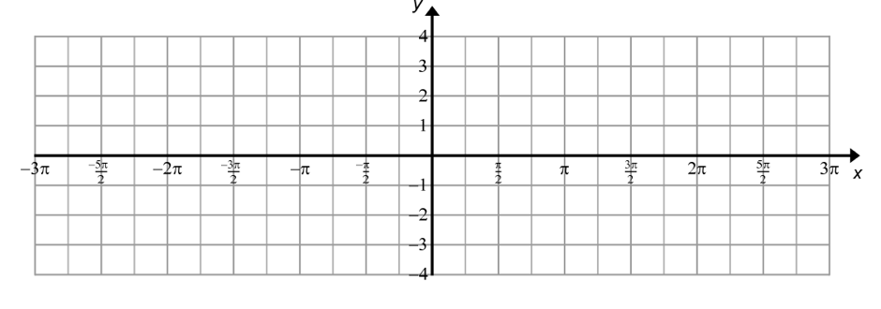
Domain:

Range:

Period:

Asymptotes:

x-intercept(s):

$$f\left(x\right)=csc(x)$$
Domain:

Range:

Period:

Asymptotes:

x-intercept(s):

$$f\left(x\right)=sec(x)$$
Domain:

Range:

Period:

Asymptotes:

x-intercepts:

$$f\left(x\right)=cot(x)$$
Domain:

Range:

Period:

Asymptotes:

x-intercept(s):

