FST Name:
3.9: Applications of Trig Functions Date: Block:

Open the Desmos Activity from the Class Lesson Plan:

Slides 1 – 4:
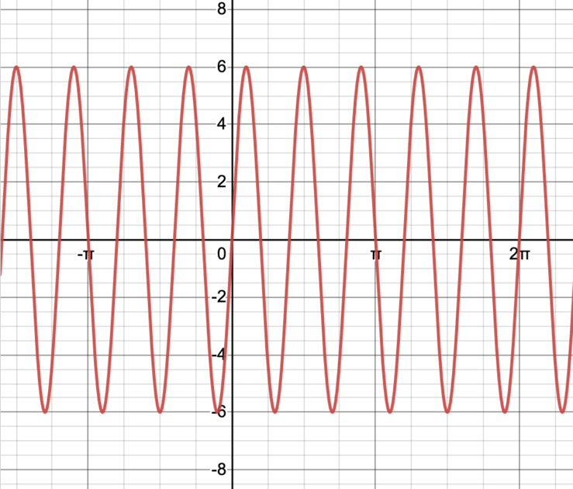

Amplitude: ________________________

Period: ___________________________

a: _______________________________

b: ________________________________

Slides 5 – 6:
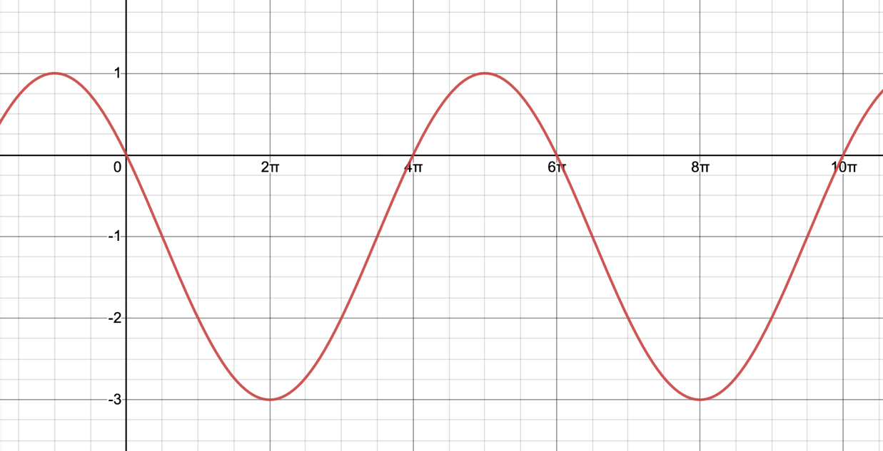

Sine Function: ____________________ Cosine Function: ________________________

Slides 7 – 8:
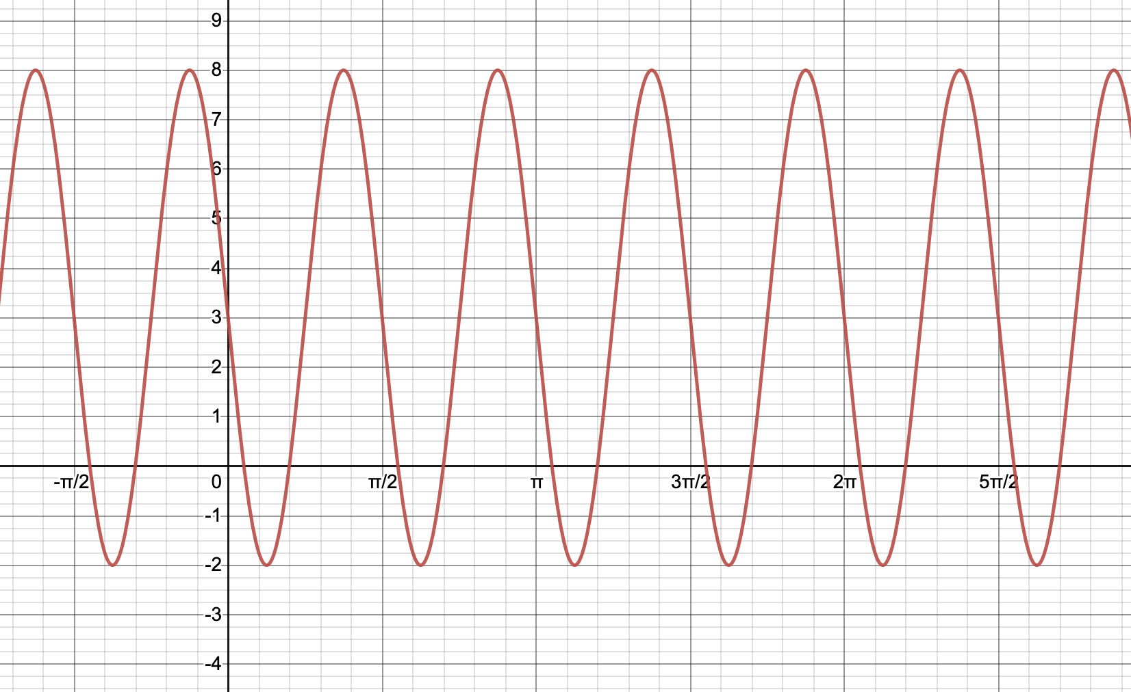

Sine Function: ____________________ Cosine Function: ________________________

Slides 9 – 14:
The Myrtle Beach SkyWheel is considered in the list of biggest ferris wheels in the US as it is 187 feet tall! It offers an incredible view of the Grand Strand to its tourists. Moreover, the wheel has climate-controlled cabins and a ticket provides three revolutions around the wheel which takes about 15 minutes. Myrtle Beach SkyWheel opened in May 2011. To get into one of the cabins a rider must climb a platform that sits 3 feet above the ground and walk into the slow-moving cabin in motion.
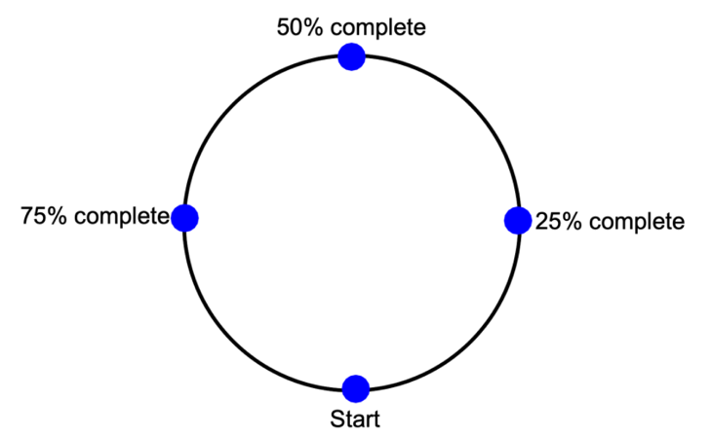

Sine Function: ____________________ Cosine Function: ________________________

