FST Name:
Notes 4.3 Date: Block:

4.3 Sums of Arithmetic Series

Warm Up: Write the explicit formula for the arithmetic sequence that has terms $a_{4}=22 and a_{8}=46.$ Then find the 25th term in the sequence? Think: how could we find the SUM of the first 25 terms in the sequence?

Sequences VS Series
Sequences | Series
Example: | Example:

Sigma Notation Evaluate the series.
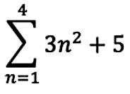
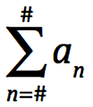

Writing in sigma notation: Consider the previous example (the warm up), how would we write the sum of the first 25 terms in the series in sigma notation?

Example. Consider the arithmetic series: $1+2+3+4+5+6$

a) Write the series in sigma notation. b) Find the sum of the arithmetic series.

What if we extended the series…. $1+2+3+4+5+6+ . . . +148+149+150.$

a) Write the series in sigma notation. b) Find the sum of the arithmetic series.

Finding the SUM of a FINITE ARITHMETIC SEQUENCE
$$Sum= S_{n}= a_{1}+a_{2}+a_{3}+ . . . +a_{n}$$ | Equation:

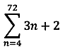
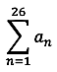
Practice.

1) If $a_{n}=5n+3,$evaluate 2) Evaluate

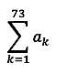

3. If $a_{k}=8+3\left(k-1\right),$ evaluate

4. If in an arithmetic sequence $p_{4}=9$ and $p_{7}=15$, answer the following questions.

a) Write the explicit formula for the sequence. b) Evaluate $p_{76}$

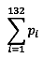

c) Evaluate $S_{76}$ d) Evaluate

5. There is a stack of logs in the backyard. There are 15 logs in the 1st layer, 14 in the second, 13 in the third, 12 in the fourth, and so on with the last layer having one log. How many logs are in the stack?

6. There are 20 rows of seats on a concert hall: 25 seats are in the 1st row, 27 seats on the 2nd row, 29 seats on the 3rd row, and so on. If the price per ticket is $2,300, how much will be the total sales for a one-night concert if all seats are taken?

