FST Name:
Notes 4.6 Date: Block:

4.6 Geometric Sums
The Sum of a Finite Geometric Series:
The sum of the first n terms of a geometric series with common ratio $r≠1$is:

Example:

Finite Sum. Given the sequence below, answer the following questions. $\left\{\begin{aligned}p_{1}=7 \\ p_{n}=4p_{n-1}, n>1\end{aligned}\right.$
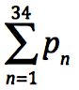
a) Find the explicit formula for the sequence.
b) Evaluate

Practice.
1) 2)

Infinite Sum. The Sum of an Infinite Geometric Series:
The sum of an infinite geometric series with first term, $a_{1}$, and
Common ratio $r$ is given by…(provided $\left|r\right|<1)$

** If $\left|r\right|≥1,$ the series diverges (has no sum).

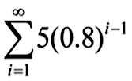
Examples. 1) 2)

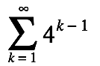
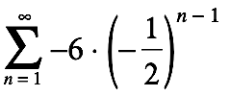
Practice.
1) 2)

Write each geometric series in sigma notation and find its sum.
1) $3+6+12+ . . . + 12,288$ 2) $200+100+50+ 25+ . . .$

Sigma Notation: ____________________ Sigma Notation: __________________________

Sum: _____________________________ Sum: ___________________________________

Word Problems.
1) Once a week Mrs. Schenkel makes sugar cookies. The first week she makes the recipe, she uses the full 2 cups of sugar called for. Each week after that, she reduces the amount of sugar by one third.
a) How much sugar does she use for the cookies on the fifth week?

b) How much sugar does she use for cookies in a six month period (half a year)?

2) A pendulum that is released to swing freely travels 18 inches on the first swing. On each successive swing, the pendulum travels 80% of the distance of the previous swing. What is the total distance the pendulum swings?

