FST Name:
Notes 5.1 Date: Block:

5.1 Exponential Growth and Decay Introduction

Explore:
Graph the following functions using Desmos and fill in the corresponding table for the given x values. What do you notice each of the functions have in common? What is different?

- $f\left(x\right)=3{(2)}^{x}$ 2.) $f\left(x\right)=6{(3)}^{x}$
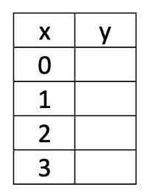
x | y
0
1
2
3

$3.) f\left(x\right)=4{(1.5)}^{x}$ 4.) $f\left(x\right)=10{(8)}^{x}$
x | y
0
1
2
3

$5.) f\left(x\right)={(\frac{1}{2})}^{x}$ 6.) $f\left(x\right)=4{(\frac{1}{4})}^{x}$
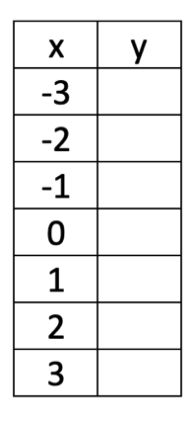
x | y
-3
-2
-1
0
1
2
3

$7.) f\left(x\right)=3{(\frac{2}{3})}^{x}$ 8.) $f\left(x\right)=20{(\frac{4}{5})}^{x}$

Parent Function: Exponential Growth and Decay Functions

Example) Label the following functions as exponential growth, exponential decay, or neither. Then give their grow/decay rate and their growth/decay factor.

$f\left(x\right)=8{(6)}^{x}$ $f\left(x\right)=100{(0.8)}^{x}$

$f\left(x\right)={\left(\frac{2}{3}\right)}^{x}$ $f\left(x\right)={9\left(\frac{10}{3}\right)}^{x}$

$f\left(x\right)={\frac{4}{7}\left(5\right)}^{x}$ $f\left(x\right)={\frac{8}{3}\left(\frac{8}{9}\right)}^{x}$

$f\left(x\right)={70\left(1.054\right)}^{x}$ $f\left(x\right)={8.45\left(1.7\right)}^{x}$

$f\left(x\right)={0.6(0.34)}^{x}$ $f\left(x\right)={0.93\left(6.3\right)}^{x}$

Example) 10 bacteria were introduced into a culture. Every minute, the bacteria will split into two pieces. Write a function where x represents the number of minutes since the bacteria was introduced to the culture and y represents the total number of bacteria. Then graph the function.

Example) A population of wolves was reintroduced into Yellow Stone Park in 1995, changing the landscape of the full park. If the initial population of wolves was 6 wolves in 1995 and the population grew at a rate of 8% per year, write a function for the total number of wolves in the population based on the number of years since the wolves arrived in 1995. Sketch a graph of the function.

Example) Mr. Tomato purchased a new (to him) vehicle for $23,468. The vehicle is said to depreciate by a rate of 17% per year. Write a function for the value of the car based on the total number of years that Mr. Tomato has owned the car. Sketch a graph of the function.

