Name: __________________

5.7 Check for Understanding (Logarithmic Scales)

1.) Read the yellow textbook and then state if you would use a linear or a logarithmic scale to plot the data.
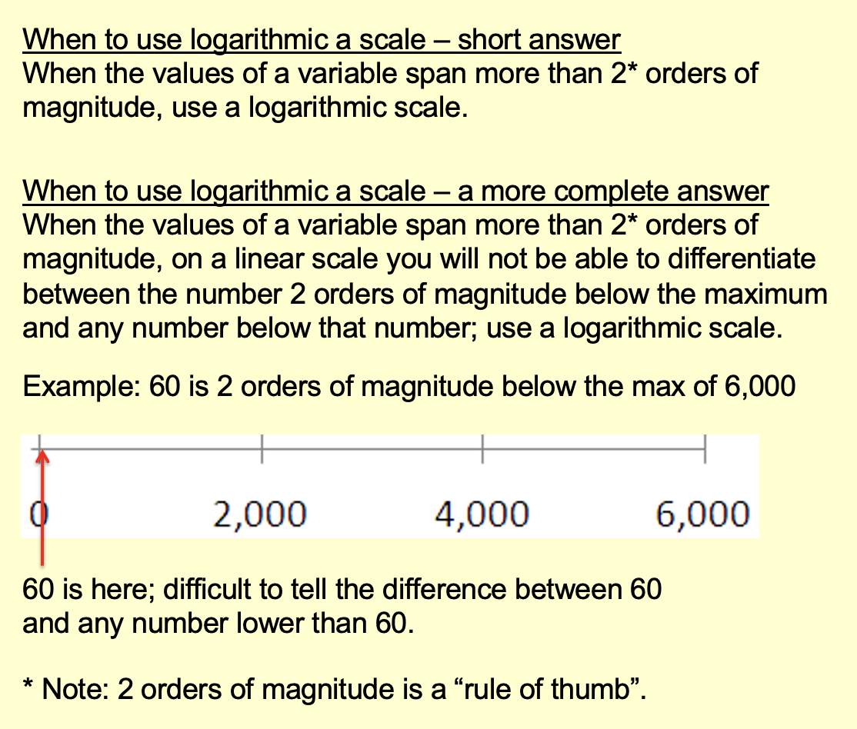
- Years from 1990 – 2010

- Years from 1500 – 2000

- Population of a country (all countries in the world included in the data set)

- Fuel efficiency of a passenger vehicle in miles per gallon

- How much a person is in debt

- Age of death of a human, rounded to the nearest year.

- Number of total heartbeats of a human in a lifetime.

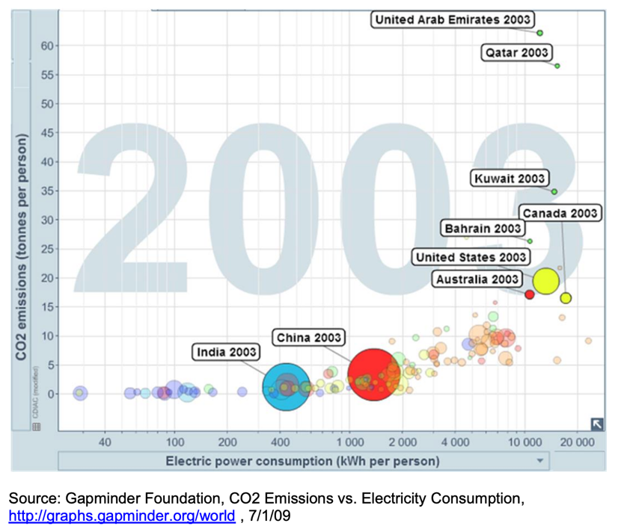
2.) Consider the Gapminder graph below. What type of scales are used on the x-axis and y-axis. Why are they used?

3.) Consider the graph below: A retail price index for UK 1694 – 1994. Explain in a complete sentence, why Holter used a logarithmic scale.
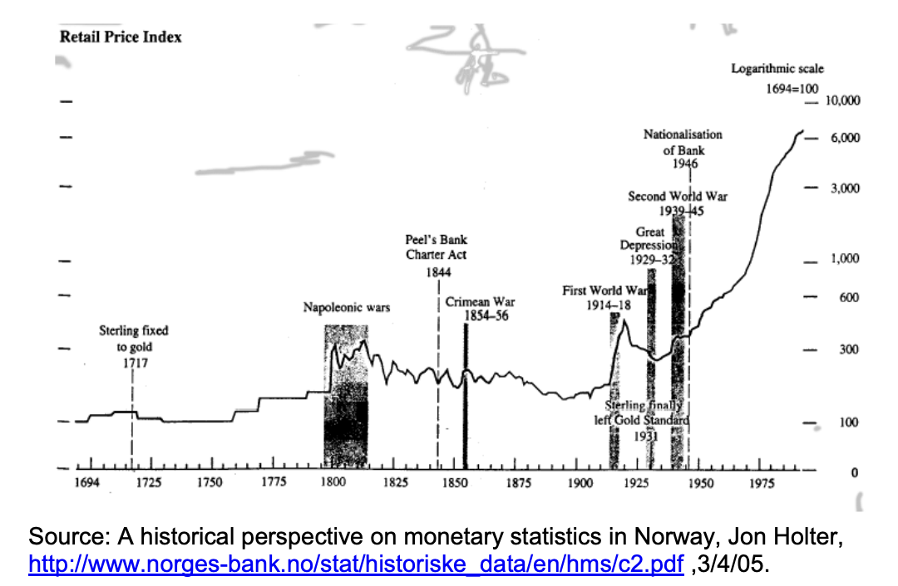

4.) Note that the graph above has a zero on the logarithmic scale. Is it mathematically correct to have zero be on a logarithmic scale?

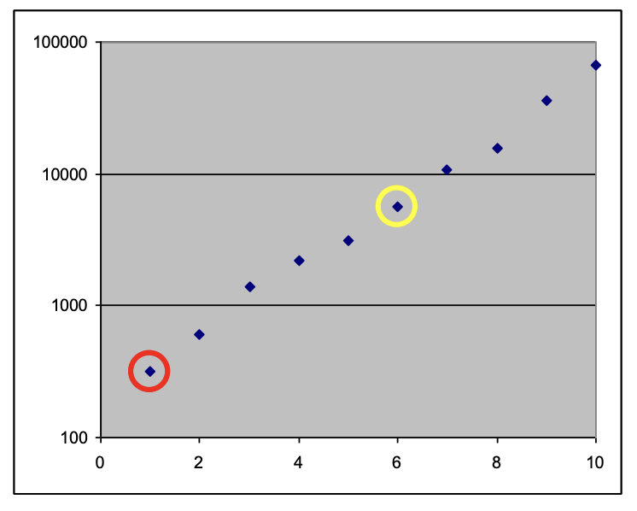
5.) Estimate the y-coordinates of the red and yellow points circled on the scatter plot.

