FST Name:
Notes 5.8 Date: Block:

5.8 Logistical Growth Models

Imagine a rumor spreading throughout a school of 2000 students. The rate at which the rumor spreads is directly proportional to BOTH the students who have heard the rumor AND the students who have yet to hear the rumor as the number of people hearing the rumor approaches 2000.
- Draw a picture that might represent the number of students who have heard the rumor.

- When do you think the rumor is spreading the fastest?

Recursive Formula for Number of Students who have Heard the Rumor

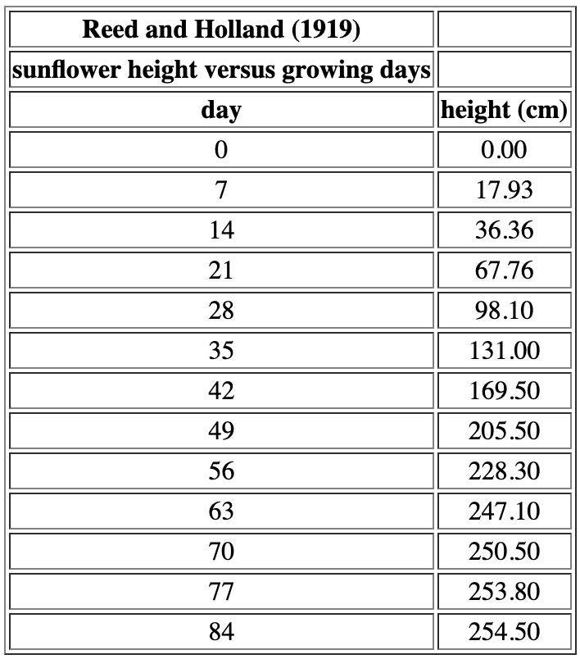
Example) Logistical Growth of a Sunflower Plant
“Individual organisms often show an S-shaped growth pattern, with rapid growth initially and little or no growth later on. S-shaped or sigmoidal growth of an individual can be caused by a number of factors. A common interpretation involves an external limit to growth based on environmental factors, such as a finite amount of food, space, or water. Growth can also be limited because of physiological factors, such as the maximum weight that bones can support.

Data on the height of a single sunflower plant as a function of time show a reasonable sigmoidal growth pattern (albeit with very fast growth early on). The sunflower grows rapidly in the first 50 days, then the growth rate slows until the sunflower reaches its maximum height of approximately 250 cm (about 8 feet tall).”

Reference: Reed, H. S. and Holland, R. H. (1919), Growth of sunflower seeds; Proceedings of the National Academy of Sciences, volume 5, p. 140.

