FST Name:
Notes 7.3 Introduction Date: Block:

7.3: Introduction (Union and Intersection)

Class Roster:

Example 1)
Lives less than or equal to 15 minutes from campus (typical) | Plays a Varsity Sport

Example 2)
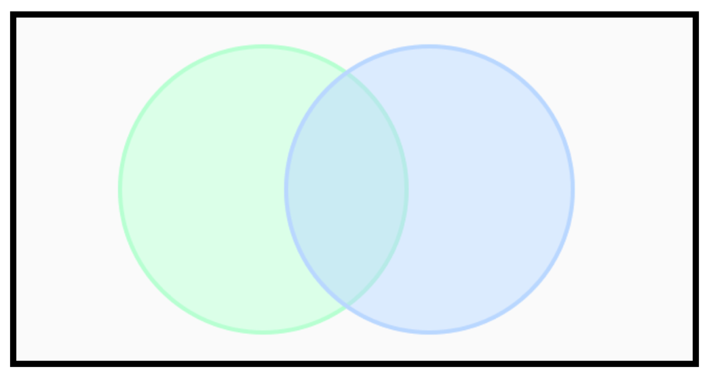

Example 3)
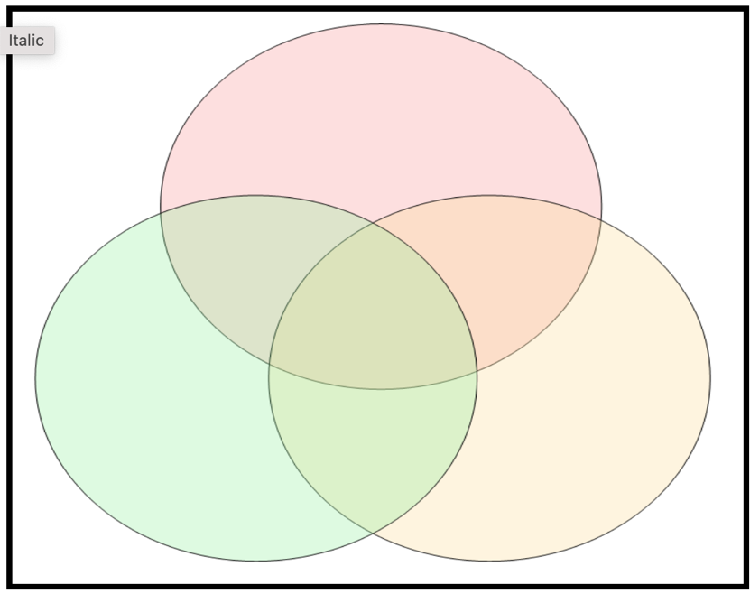
Taller than 55 inches | Blue or Green Eyes | Hair is longer than ear

Example 4)

