FST Name:
Unit 3 Review Date: Block:

Chapter 3 Review Worksheet (3.1-7)

Show all of your work and follow all directions. You may use a calculator on any problem that contains an *.
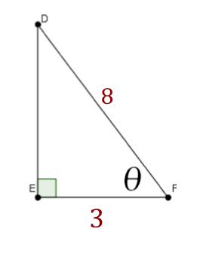
1.) Evaluate the six trigonometric expressions given the triangle defined below.

sin(ϴ) = csc(ϴ) =

cos(ϴ) = sec(ϴ)=

tan(ϴ)= cot(ϴ)=

2.) Let ϴ be an acute angle of a right triangle such that cot(ϴ) = 4/7. Find the values of the other five trigonometric functions of ϴ.
sin(ϴ) = csc(ϴ) =

cos(ϴ) = sec(ϴ)=

tan(ϴ)= cot(ϴ)=

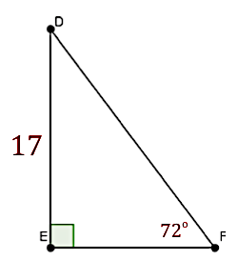
*3.) Solve the triangle using the given measurements.

<D = d =

< E = e =

< F = f =

4.) Evaluate the following trigonometric expressions.

a) sin(30º) = b) tan(60⁰) = c) csc(45⁰) =

d) cos(60⁰) = e) cot(45⁰) = f) sin(45⁰) =

g) sec(30⁰) = h) csc(30⁰) = i) cos(60⁰) =
*5.) A passenger in an airplane flying at an altitude of 25,000 feet sees two towns directly to the left of the plane. The angle of depression from the passenger to the closest town, Town X, is 25º. The angle of depression from the passenger to the further town, Town Y, is 15º. What is the distance from the airplane to Town X? What is the horizontal distance from the airplane to Town X. What is the distance between Town X and Town Y?

6.) Convert from radians to degrees.
a) b) c)

7.) Convert from degrees to radians.
a) 36º b) 220⁰ c) -135º

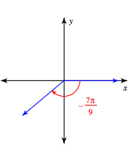
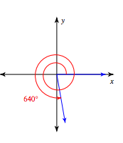
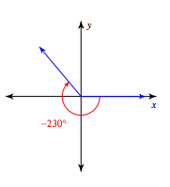
8.) For each angle give two coterminal angles (one positive and one negative) and its reference angle. Circle your coterminal angles and box your reference angle. Work in the measurement the original angle is given.

a) b) c)

9.) For each angle sketch the angle in standard position. Then give two coterminal angles (one positive and one negative) and its reference angle. Circle your coterminal angles and box your reference angle. Work in the measurement the original angle is given.
a) 178º b) $\frac{7π}{9}$ c) $\frac{13π}{4}$

10.) Are the following pairs coterminal angles?
a) 185º, -545º b) 140º, -220º c) $\frac{3π}{4}, \frac{13π}{4}$ d) $-\frac{π}{6}, \frac{13π}{6}$

11.) A jet is flying at an altitude of 30,000 feet. An air traffic controller measures the angle of elevation to the plane to be $17°$. Find the horizontal distance of the plane from the airport.

12.) A kite string is 200 meters long. Find the height of the kite if the string makes an angle of $38°$ with the ground.

13.) A fire department’s longest ladder is 110 feet long, and the safety regulation states that they can use it for rescues up to 100 feet off the ground. What is the maximum safe angle of elevation for the rescue ladder?

14.) Evaluate the following trigonometric expressions.

a) $cos\left(\frac{11π}{6}\right)$ b) $sin\left(\frac{4π}{3}\right)$ c) $cot\left({315}^{o}\right)$

d) $csc\left(\frac{3π}{2}\right)$ e) $sec\left(\frac{3π}{4}\right)$ f) $cos\left({210}^{o}\right)$

g) $cos\left(π\right)$ h) $csc\left(-\frac{π}{4}\right)$ i) $sec\left({90}^{o}\right)$

j) $sin\left(\frac{7π}{6}\right)$ k) tan$\left(-\frac{4π}{3}\right)$ l) $sin\left({-510}^{o}\right)$

m) $sec\left(\frac{17π}{6}\right)$ n) $tan\left(-\frac{10π}{3}\right)$ o) $cos\left(5π\right)$

