Name: ___________________________

Chapter 7.1-3 Check for Understanding

Follow all directions and show all of your work in order to receive full credit. Box your final answers.

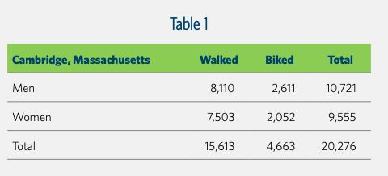
1.) A survey was given to 20,276 persons in Cambridge, MA asking them their gender identification and if they walked or biked to work. Persons who did not walk or bike to work were not recorded in either table. Use the table to answer the following questions.

a) What does 8110 represent? Answer in a complete sentence.

b) Calculate RF(Biked) c) Calculate RF(Woman AND Biked)

d) Calculate RF(Walked | Man) e) Calculate RF(Man OR Walked)

f) Calculate RF(Women | Biked) g) Calculate RF(did not Walk to work)

h) What does $\frac{2,611}{4,663}$ represent. You can answer in a complete sentence OR mathematical notation.

2.) Given a 40% chance of rain today, a 50% chance of rain or lightning, and a 20% chance of rain and lightning, what is the probability that it will lightning today?

3.) A class of 30 fifth graders were asked if they like to put ketchup and/or mustard (or neither) on their hot dogs. Of the 30 responses, 16 responded that they like ketchup, 12 responded that they like mustard, and there were 6 students who didn’t like either. Fill in the Venn Diagram. Then use the venn diagram to help you answer the questions below.

If one student is randomly selected from the class of 30 fifth graders, what is the relative frequency that they…..

a) like both ketchup AND mustard on their hot dog

b) like only mustard on their hot dog

c) like ketchup OR mustard on their hot dog

4.) A football team has a 70% chance of winning when it does not snow, but only a 40% chance of winning with it does snow. Suppose there is a 50% chance of snow for the next game on Friday night. What is the probability that the team will win? It may help to make a tree diagram for this problem, but it is not required. Box your final answer.

5.) Two marbles are selected from a bag that contains 11 blue marbles, 8 green marbles, and 3 red marbles without replacement. What is the probability that a green marble is selected and then a blue marble is selected?

6.) A card is drawn from a standard deck of 52 cards. What is the probability that the card is…

a) an ace OR an eight b) a face card AND a heart

______________________________ ______________________________

7.) P(A) = 0.83. What is P(~A)?

______________________________

8.) Felix has 10 blue shirts, 4 black shirts, 3 red shirts, and 2 green shirts in his closet. He chooses a shirt to wear each morning and then throws it in the dirty clothes hamper at the end of the day. What is the probability that he chooses a blue shirt, then a red shirt, a green shirt, a black shirt, and then another blue shirt to wear during one school week (Monday – Friday)?

______________________________

