Name: ________________________

Check for Understanding 1.4 – 5

- Open the CODAP file titled Movie Ticket Sales and analyze the data (be sure to include all of the elements of analyzing the data).

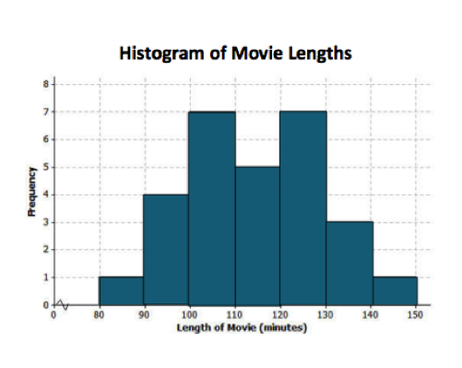
- The histogram below represents the lengths of a set of movies in minutes.

- What does the 2nd bin from the left represent? Answer in a complete sentence.

- What is the bin width for this histogram?

- How many total movies are represented in this histogram?

- What percent of movies represented in the histogram had a length of $110≤x<120$ minutes?

