Name: _________________________

**Check for Understanding 2.5 – 7**

**1 – 2] Graph the following functions using your knowledge about transformations. Identify the parent function and fill in the information that is asked**

**1.) $y=-\frac{3}{4}|x+5|+3$**

Parent Function: ___________________

Domain: __________________________

Range: ____________________________

Vertex: ____________________________

Increasing: _________________________

Decreasing: ________________________



**2.) $y=\frac{1}{x+3}-7$**

Parent Function: ___________________

Domain: __________________________

Range: ____________________________

Asymptotes: _______________________

Increasing: _________________________

Decreasing: ________________________

**3 – 5] Write a model for each graphed function.**

**3.)**

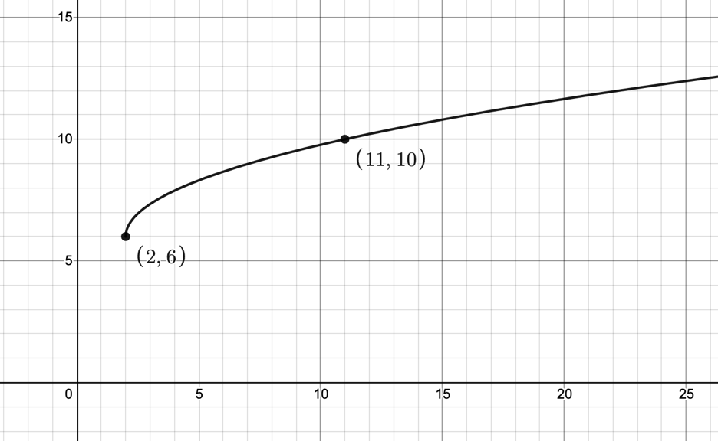

**4.)**

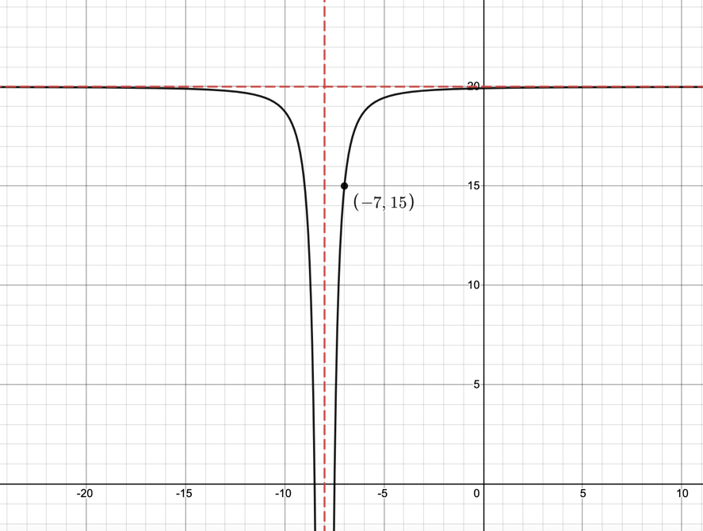

**5.)**

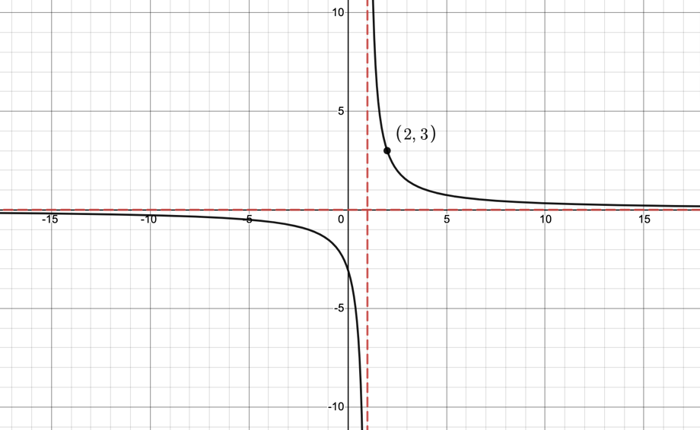

**6.)** Open up the CODAP file titled [Batting Practice](https://codap.concord.org/app/static/dg/en/cert/index.html#shared=https%3A%2F%2Fcfm-shared.concord.org%2FhrhxlY1Cwtexu2TeqFao%2Ffile.json). In an experiment the data in the table was gathered to determine the distance a ball traveled in feet when it was hit at the given angle in degrees at a constant bat velocity of 100 mph. Complete the questions below in the CODAP file and email instructor your completed file.

a) Analyze the Data using angle as the independent variable and distance as the dependent variable.

b) What is the optimal angle that a ball should be hit at in order to travel the maximum distance if the ball is hit at a constant bat velocity of 100 mph?

c) If the distance traveled by a ball is 165 feet, what angle(s) could the ball have been hit at?

**7.)** Open the CODAP file titled [Olympic Men’s Long Jump](https://codap.concord.org/app/static/dg/en/cert/index.html#shared=https%3A%2F%2Fcfm-shared.concord.org%2FLE4FpU3PDWpUIfQt796W%2Ffile.json). The data in the table represents the distance of the Olympic Gold Medalists for each year. Complete the questions below in the CODAP file and email your instructor your completed file.

a) Analyze the Data using year as the independent variable and jump distance as the dependent variable.

b) According to your model, how far is the Gold Medalist of the 2028 Olympics Men’s Long Jump predicted to jump?

c) According to your model, in what year is the Gold Medalist of the Men’s Long Jump in the Olympics predicted to jump 8.7 meters?