TASK 2: Daylight Hours

Assignment:
Step 1:
Choose a specific city/region anywhere in the world. Research the average daylight hours for each month for one full year. Calculate the average daylight hours for each month for one full year, giving you 12 data points. You cannot use Boston, MA because that is what I’ve outlined below.

For example, let’s say you research the daylight hours for Boston, MA for the year 2020. The following website gives me the daylight hours for each day. https://www.timeanddate.com/sun/usa/boston?month=1&year=2021
I can calculate the AVERAGE daylight hours for each month in a specific year and that will give me 12 data points where the x coordinate is the month of the year (for example July would have an x value of 7 and November would have an x value of 11) and the y coordinate is the average daylight hours for that month. The website takes you to January of 2021. Adding up the total number of daylight hours for all 31 days and then dividing 31 gives me an average daylight hours for the month of January 9 hours and 59 minutes which is 9.98 hours (.98 equals 59/60 minutes). My data point would be (1, 9.98) with 1 representing January and 9.98 representing total daylight hours.

Be sure to gather all of the information you need to complete a full MLA citation for where you got the information you used. This will need to be included on your final product.

Step 2:
Once you have gathered all 12 data points, plot them in a scatterplot. Desmos is a great tool for you to use. When you go to the graphing tool you can select + in the upper left corner and then table to type in your data values (picture below).
Step 3: 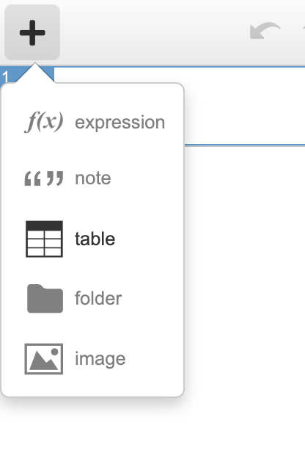
Determine the amplitude and period of the motion you see. Once you determine the amplitude and period, then determine the “a” and “b” value of your sine/cosine function.

Amplitude: _____________ Period: _____________

a: _____________ b: _____________

Step 4:
Create a sine and cosine function that models your scatterplot from from Step 2. Use the information you’ve outlined in Step 3 to help create your functions. Graph your sine and cosine function in conjunction with the scatterplot to ensure they closely match!

Sine Function: ___________________

Cosine Function: ___________________

Step 5:
Create your final product that you will turn in.

Assessment Product (what you turn in)

You will hand in a virtual poster (one page) that showcases the information about the daylight hours of one full calendar year of the place you researched. Your virtual poster must include the following information:
- 12 data points (Citation for where you got your data)
- Scatterplot of the data points solely
- Amplitude and Period of the wave
- Sine Model for the daylight hours
- Cosine Model for the daylight hours
- Graph of the Sine Model with the scatterplot
- Graph of the Cosine Model with the scatterplot

Your virtual poster should clearly show the information above. It should be aesthetically pleasing and creative. Canva.com has many good templates and there are many other great resources for you to use. The final poster should be submitted as a PDF. The scoring rubric for this project is available here.

