Lesson 3.8: Graphs of Sine, Cosine, and Tangent Functions

SINE FUNCTION
y = sin(x)

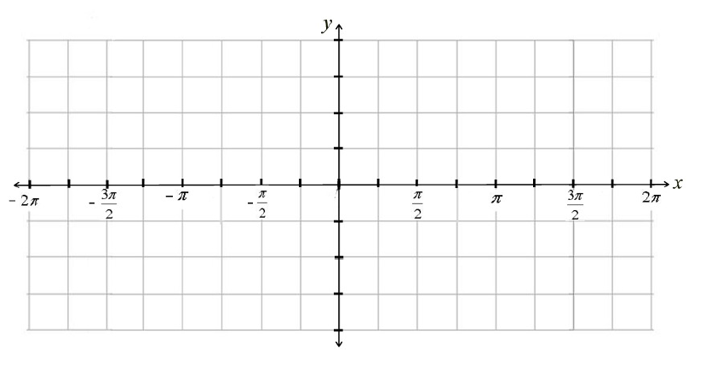
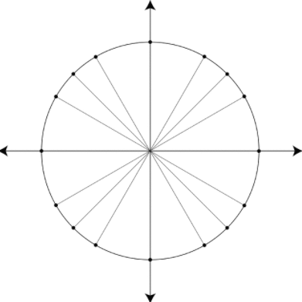

Domain: Range:

*Amplitude: *Period:

x-intercepts: y-intercept:

Lesson 3.8: Graphs of Sine, Cosine, and Tangent Functions

COSINE FUNCTION
y = cos(x)

Domain: Range:

*Amplitude: *Period:

x-intercepts: y-intercept:

Lesson 3.8: Graphs of Sine, Cosine, and Tangent Functions

TANGENT FUNCTION
y = tan(x)

Domain: Range:

*Amplitude: *Period:

x-intercepts: y-intercept:

