Linear and Quadratic Trifold Project Directions

Folder is to be graded as a major assessment (steps 1 – 3).
Problem Set 2.1 is to be graded as a minor assessment (Step 4).

Step 1: Glue two manila folders together to create a trifold presentation board.

Step 2: Split the left side of your trifold into three equal pieces as pictured below and label them Point Slope Form, Slope Intercept Form, and Standard Form as pictured below. Follow the directions below regarding each section. You must use a different equation for each form (3 distinct examples). One equation must contain a negative slope, one must contain a positive slope such that 0 < m < 1, and one must contain a positive slope.

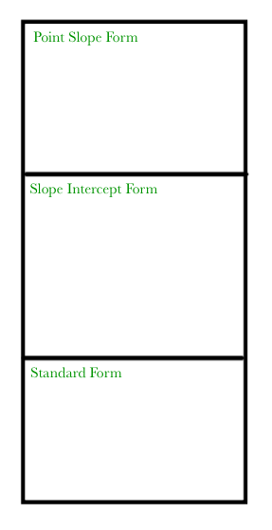
1. In the space labeled Point Slope Form, give an example of a linear equation written in point slope form. Graph the equation on a coordinate plane. Give the x- and y- intercepts of the equation. Give the domain and range of the equation. Then write the equation in slope intercept and standard forms.

2. In the space labeled Slope Intercept Form, give an example of a linear equation written in slope intercept form. Graph the equation on a coordinate plane. Give the x- and y- intercepts of the equation. Give the domain and range of the equation. Then write the equation in point slope and standard forms.

3. In the space labeled Standard Form, give an example of a linear equation written in standard form. Graph the equation on a coordinate plane. Give the x- and y- intercepts of the equation. Give the domain and range of the equation. Then write the equation in point slope and slope intercept forms.

Step 2: Split the right side of the folder into four even spaces. Label each space with the labels (Parallel Lines, Perpendicular Lines, Vertical and Horizontal Lines, Intersections of Lines) as pictured below.

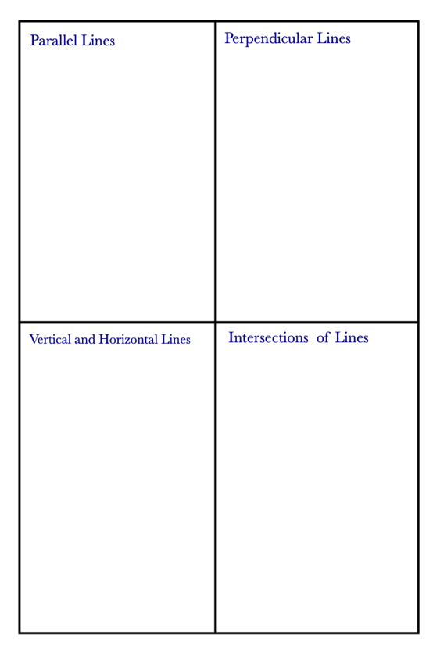
1. In the space labeled Parallel Lines, give an example of two parallel lines (slope of lines cannot be zero or undefined). Label them lines m and n. Graph them on the same coordinate plane.

2. In the space labeled Perpendicular Lines, give an example of two perpendicular lines (slope of lines cannot be zero or undefined) Label them lines a and b. Graph them on the same coordinate plane.

3. In the space labeled Vertical and Horizontal Lines, give an example of a vertical line and a horizontal line. Label them lines p and r. Graph them on the same coordinate plane.

4. In the space labeled Intersection of Lines, find the intersection of lines m and p using one algebraic method, showing all of your work. Then graph lines m and p on a coordinate plane to verify your algebra is correct.
m: 4x + 3y = 12
p: 2x – y = 11

Step 3: Split the middle part of the folder into two equal spaces using a horizontal line. In the top half, split the folder into three equal pieces using vertical lines. Label each space with the labels (Standard Form, Vertex Form, and Intercept Form) as pictured below. In the bottom half, split the folder into four equal pieces using one vertical and one horizontal line. Label each space with the labels (Taking a Square Root, Factoring, Completing the Square, and The Quadratic Formula) as pictured below.

1. In the space labeled standard form given an example of a quadratic function in standard form. Graph the quadratic on a coordinate axis, labeling the vertex and at least one other point on the quadratic. Then give the axis of symmetry, vertex, domain, and range of the quadratic function.

2. In the space labeled vertex form given an example of a quadratic function in vertex form. Graph the quadratic on a coordinate axis, labeling the vertex and at least one other point on the quadratic. Then give the axis of symmetry, vertex, domain, and range of the quadratic function. *Must be different from your quadratic in standard form*

3. In the space labeled intercept form given an example of a quadratic function in intercept form. Graph the quadratic on a coordinate axis, labeling the x-intercepts and vertex of the quadratic. Then give the axis of symmetry, vertex, domain, and range of the quadratic function. *Must be different from your quadratic in standard and vertex forms*

4. In the space labeled “Taking a Square Root” give an example of a quadratic equation that you would take a square root to solve. Write a complete sentence explaining why taking the square root is the easiest method to use.

5. In the space labeled “Factoring” give an example of a quadratic equation that you would factor to solve. Write a complete sentence explaining why factoring is the easiest method to use.

6. In the space labeled “Completing the Square” give an example of a quadratic equation that you would complete the square to solve. Write a complete sentence explaining why completing the square is the easiest method.

7. In the space labeled “Quadratic Formula” give an example of a quadratic equation that you would use the quadratic formula to solve. Write a complete sentence explaining why completing the square is the easiest method.

Step 4: Complete Problem Set 2.1 Exercises and turn in with your folder.

