FST Name:
Problem Set 2.5 Date: Block:

Problem Set 2.5

- The function f(x) is graphed below. List the transformations being done to the parent and then graph g(x).
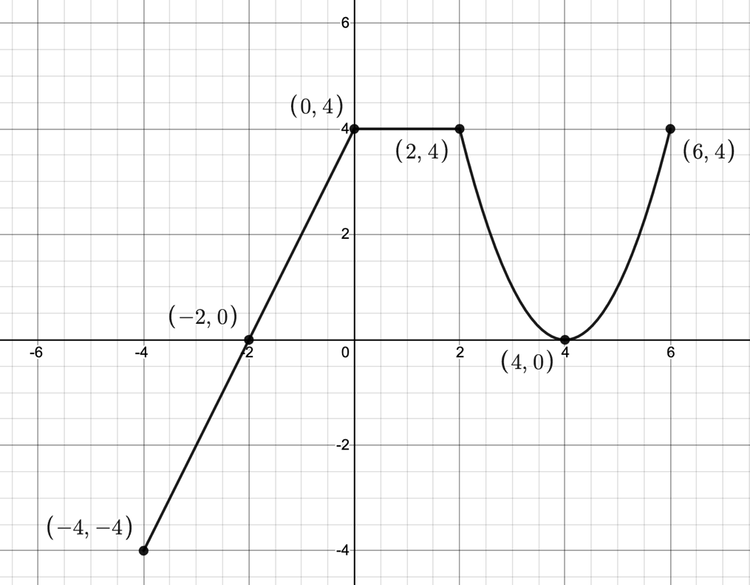

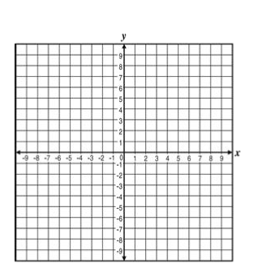

- $g\left(x\right)=3f\left(x\right)$

b) $g\left(x\right)=f(2x)$

$c) g\left(x\right)=f\left(x-5\right)+3$

d) $g\left(x\right)=-f(x+6)$

$e) g\left(x\right)=2f\left(-x\right)+5$

f) $g\left(x\right)=f(4x+8)$

g) $g\left(x\right)=-f\left(-x\right)-4$

