Name: _________________________________

Problem Set 2.8

Statistical software packages like CODAP often give r² (or r^2 or R²) which is the Coefficient of Determination. The Coefficient of Determination tells the proportion of the variation of the dependent variable that is accounted for by the least-squares regression line. When CODAP gives r², $\sqrt{r^{2}}$gives |r| and the slope of the least-squares line tells us the sign of r, that is, whether r is positive or negative.

1.) Find r for the following scatter plot.
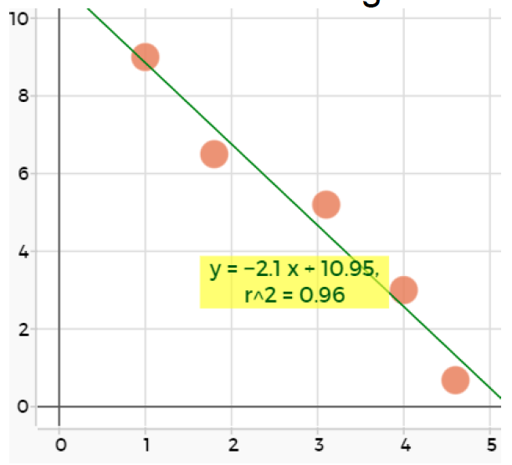

In 2 – 4, complete the sentence.

2.) If r (the correlation coefficient) is positive then, …

3.) If r² (the coefficient of determination) is 0.99 then, …

4.) If your statistics software gives you r² = 4, …

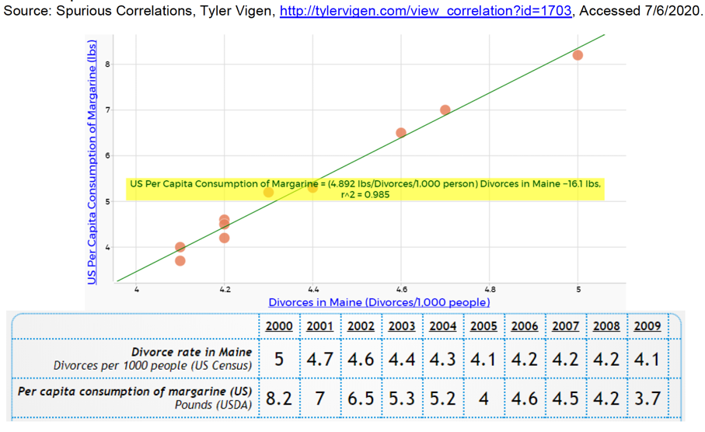
5.) From 2000 – 2009, there was a very strong positive linear correlation between divorces in Maine and the US per capita consumption of margarine. Did a rise in US margarine consumption CAUSE more Maine divorces?

6.) Use CODAP to open the data set titled Average Global Temp vs. CO2
Earlier in this chapter you found a model that predicted the Average Global Temperature as a function of year. This time, use Average Global Temperature as the independent variable and Average Global Concentration of CO2 as the dependent variable.
a) Find the least-square line.

b) What is the meaning of the slope within the context of the data set?

c) What is the correlation coefficient and what information does the correlation coefficient provide within the context of the data set?

7.) Use CODAP to open the data set titled Car Skids

Just before a car accident, a driver often slams on the brakes and creates a skid mark. Police can use the length of the skid mark to determine the approximate speed the car was going, just prior to braking. Open the Car Skid data set and use Skid Length as the independent variable and Speed as the dependent variable.
a) Find the least-square line.

b) What is the meaning of the slope within the context of the data set?

c) What is the correlation coefficient and what information does the correlation coefficient provide within the context of the data set?

d) Is the linear model appropriate? Why or why not?

