Name: ___________________________________

Problem Set 6.2
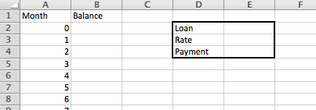

You are creating a spreadsheet to model the balance on a loan you took out for a car. You are going to use cells E2, E3, and E4 to write formulas to see how much you will owe on the loan at the end of each month.

1. What would you type in cell B2? 2. What would you type in cell B3?

=E2 =B2(1 + (E$3/12)) – E$4

3. What is the monthly payment (to the nearest penny) to pay back a loan of $11,032 in 60 months at an annual interest rate of 6.3%?

$214.82

a. What is the balance of the loan after month 30? (Half of the term of the loan is complete)

$5948.36

4. If you could afford to pay $287 per month for a 36 month loan at 4.7% interest, how much can you afford to borrow from the bank (what is the loan amount) to the nearest penny?

$9619.12

5. Interest Rates are offered to a person primarily based on their credit score. The interest rates for a person with Excellent, Good, Fair, and Poor credit ratings are in the table below. (https://www.experian.com/blogs/ask-experian/credit-education/score-basics/what-is-a-good-credit-score/). Peter has decided to purchase a car that costs $32,000. He has saved $5,000 for a down payment and plans to use a 60 month term for his loan. Use the table below to determine the monthly payment, total dollars paid and total interest paid if he has the following credit scores and is offered the following interest rates.

Credit Rating | Interest Rate
Excellent (770) | 3.8%
Good (700) | 5.4%
Fair ( 660) | 14.6%
Poor (570) | 26.4%

Credit Rating | Monthly Payment | Total $$$s paid | Interest Paid
Excellent | $494.81 | $29,688.78 | $2,688.78
Good | $514.49 | $30,869.17 | $3,869.17
Fair | $636.67 | $38,200.38 | $11,200.38
Poor | $814.80 | $48,887.94 | $21,887.94

