Name: ____________________________

Problem Set 1.1: Comparative Statistics

Mark Twain – “If you don’t read the newspaper you are uninformed, if you do read the newspaper you are misinformed.”

- How can Oscar Mayer claim that the turkey is 98% fat free when almost 20% of the calories come from fat?

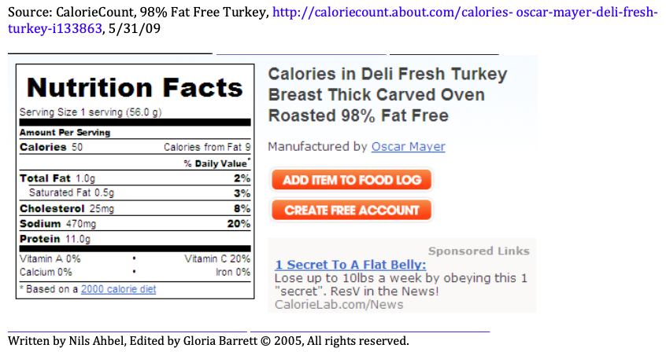

- The article, “El Nino Seen as Trigger for Violence in the Tropics,” reports that from 1950 to 2004 civic conflict was more likely to occur in tropical countries during El Nino years. (El Nino, the opposite of La Nina, results in most tropical countries experiencing hotter, drier weather). There was 3% chance of conflict during La Nina and that rose to 6% during El Nino. This change can be exaggerated or diminished depending on the way you compare 3% and 6%. Use subtraction, division, and percent change to create three comparative statistics.

Subtraction:

Division:

Percent Change:

For 3 – 6, refer to the table at the bottom of the page.

- How many crimes were perpetrated in the US in 1995?

- What percentage of the total crimes were violent crimes?

- What percentage of the Property Crime in Metropolitan Areas was Motor Vehicle Theft?

- Write a complete sentence that fully describes what the number 234, found in the Violent Crime row, means. Write the sentence in the style of a newspaper article?

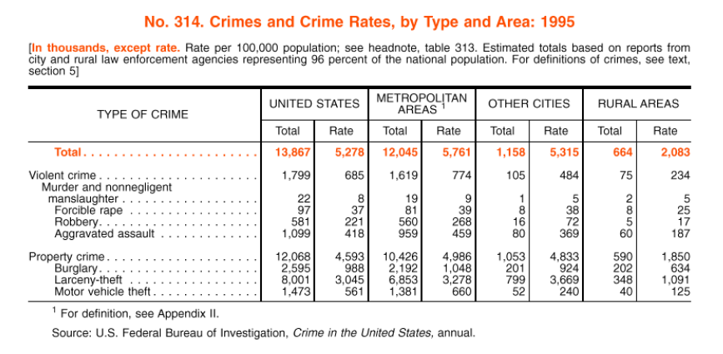
For 7- 8, refer to the table at the bottom of the page.

- How many families received child support that had incomes of $15,000 and over?

- Consider the unemployment compensation of white families.
  - What percentage of white families receiving specified sources of income received unemployment compensation?

  - What percentage of families who received unemployment compensation were white?

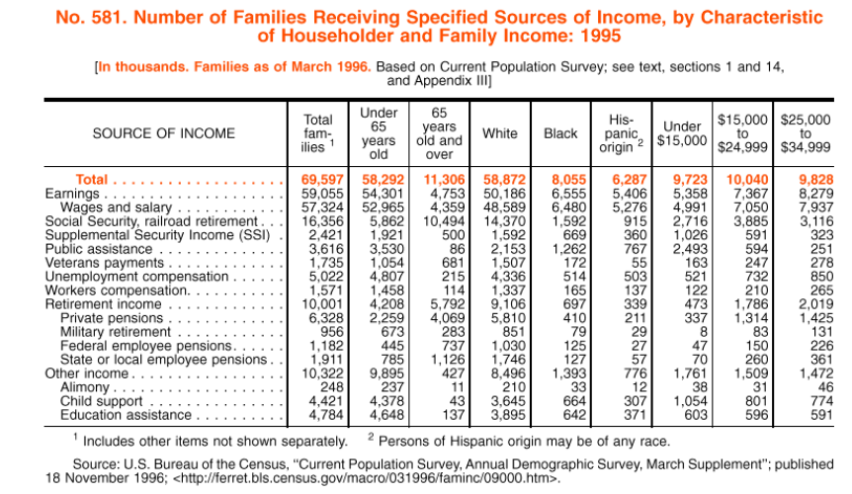

For 9 – 10, refer to the table at the bottom of the page. *1 ton = 2000 pounds*

- How many pounds of Waste were generated in the US in 1995?

- In 1995, were “Other Nonferrous Metals” a problem as far as recovery is concerned?

For a. and b. below, write as if the sentences will appear in a newspaper article.

- Write a sentence that convinces that Other Nonferrous Metals are recovered the MOST of all materials.

- Write a sentence that convinces that Other Nonferrous Metals are recovered the LEAST of all materials.

