Name: ______________________________________

Problem Set 2.3: Analyzing Bivariate Data with Linear Models

1. Vitruvian Man (also called Canon of Proportions) is a famous drawing by Leonardo da Vinci that shows the proportions of man based on the Vitruvian text, “On Symmetry: in Temples and in the Human Body”. Open the CODAP file called “Vitrivian Man”. It contains a collection of ordered pairs of measurements of the picture shown. The independent variable will be wingspan in cm (to the nearest tenth). The dependent variable will be height (without shoes) in cm (to the nearest tenth).
a) “Analyze the Data” – Save your CODAP folder which
includes your scatter plot, curve fit to the data,
and residual plot.

b) Write a sentence that explains the meaning of the
slope of your linear model within the context.

c) Write a sentence that explains the meaning of the
point (h,k) in your linear model within the context.

d) Measure your arm span. Use your model
(the equation, not the graph) to predict your height?
Show your algebraic work. How close was your model
(what is the residual)?

2. Open the data set called “Car MPG Vs. Weight”

a) “Analyze the data” – Save your CODAP file which includes your scatter plot, curve fit to the data, and residual plot.

b) Write a sentence that explains the meaning of the slope of your linear model within the context.

c) Use your model to predict what the Fuel Efficiency (MPG) would be for a car weighting 2700 pounds. Show your algebraic work.

d) According to the slope of your model, what is the effect on fuel efficiency of taking on a passenger in your car that weighs 175 pounds? Show your algebraic work.

3. Open the data set called “CO₂ Annual 2000-2019”
Since the beginning of the industrial revolution there has been an ever increasing concentration of carbon dioxide (CO₂) in our atmosphere. High levels of CO₂ in our atmosphere result in a greenhouse effect, which has led to global warming. CO₂ concentration in air is usually measured in parts per million by volume (ppmv). Just prior to the industrial revolution CO₂ concentrations were about 280 ppmv. By 2008 CO₂ concentrations reached about 385 ppmv. There is a growing consensus among scientists that specialize in global warming that 450 ppmv is a threshold above which disastrous, irrevocable changes would affect the planet.

a) “Analyze the data” – Save your CODAP file which includes your scatter plot, curve fit to the data, and residual plot.

b) Write a sentence that explains the meaning of the slope of your linear model within the context.

c) According to your model, in what year will CO₂ concentration reach 450 ppmv? Show your algebraic work.

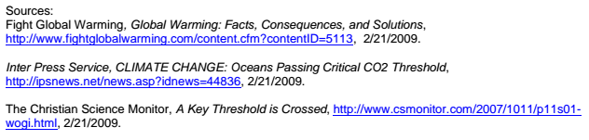
4. Open the data set called “Tried Marijuana before age 13”
The number of teenagers that have tried marijuana before age 13 has been decreasing since 1999.
a) “Analyze the data” – Save your CODAP file which includes your scatter plot, curve fit to the data, and residual plot.

b) Write a sentence that explains the meaning of the slope of your linear model within the context.

c) According to your model, how long will it take the percent of teenagers who try marijuana before age 13 to drop 3%? Show your algebra.

