Name: ____________________________________

Problem Set 2.4 – Analyzing Bivariate Data with Quadratic Functions

- Open “Ball Toss” in CODAP.
  - “Analyze the data” Make sure you save your codap file, showing your model and residuals.

b. According to your model from (a), approximately when will the ball be at 3.6 seconds?

c. According to your model from (a), approximately what time(s) will the ball be 1 meter high?

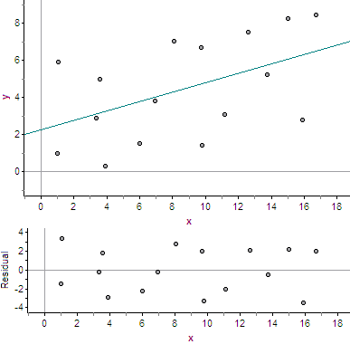
- Consider the scatterplot with linear model and the corresponding residuals.

  - Comment on the residuals.

  - Comment on the appropriateness of the model.

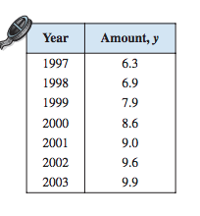
3) The table shows the amounts (in billions of dollars) spent on admission to movie theaters in the US for the years 1997 to 2003.

a) Use CODAP to create a linear model for the data. Let
the independent variable (x) be the number of years since
1997 and the dependent variable (y) be the dollar amount
spent on admission to movie theaters in the US in billions.
Then “analyze the data”.

b) Now use CODAP to create a quadratic model for the data. Let
the independent variable (x) be the number of years since
1997 and the dependent variable (y) be the dollar amount
spent on admission to movie theaters in the US in billions.
Then “analyze the data”.

