Problem Set 3.5

1.) Fill in the degree and radian measures for the unit circle without referring to your notes.
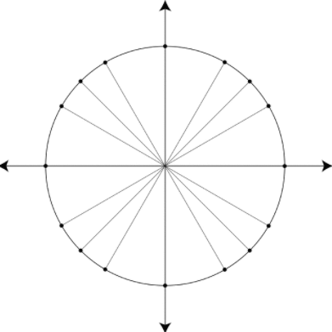

2.) Fill in the missing side lengths of each triangle. (Use your special right triangles)

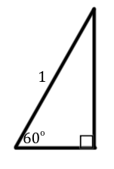
- b) c)
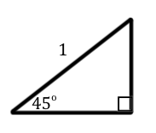
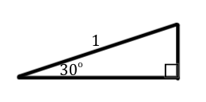

3.) What are the coordinates of the points on the unit circle?
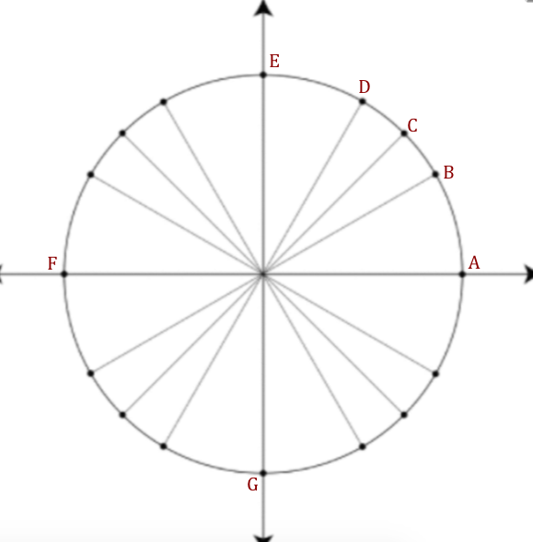

A: ________________

B: ________________

C: ________________

D: ________________

E: ________________

F: ________________

G: ________________

4.) In the picture below the points B, C, and D, are the same points from number 3. Points H, I, and J correlate to the points on the unit circle that lie on the terminal side of angle measures 120º, 135º, and 150º respectively. How do you think the coordinates of points H, I, and J compare to the coordinates of points B, C, and D? Are they related at all?
