Name: __________________________
Problem Set 3.7
Follow all directions and show all of your work in order to receive full credit.
1. Fill out the degrees and radians of the unit circle from memory for practice. Fill in the missing angles and side lengths of the 30-60-90 and 45-45-90 triangles from memory.
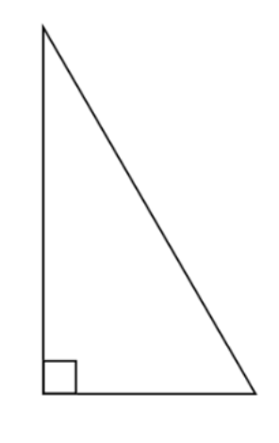
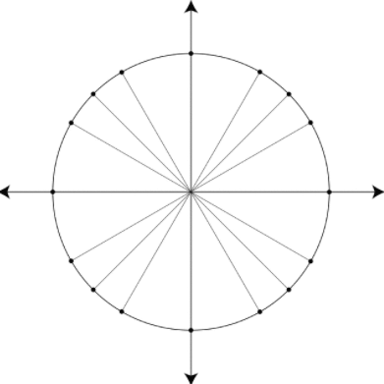

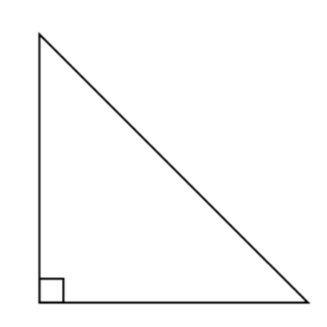

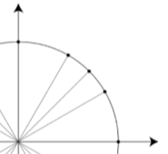
2. Give the terminal points for the three angles (30º, 60º, 45º) in the first quadrant.

3 – 17] Evaluate the trigonometric expressions.
3) $csc\left(\frac{17π}{6}\right)$ 4) $cos\left(-\frac{23π}{6}\right)$ 5) $tan\left(8π\right)$

6) $sin\left(\frac{5π}{2}\right)$ 7) $sin\left(\frac{8π}{3}\right)$ 8) cos(660º)

9) $cos\left(-7π\right)$ 10) $sin\left(-\frac{13π}{4}\right)$ 11) sec (450º)

12) $cos\left(\frac{4π}{3}\right)$ 13)$sin\left(9π\right)$ 14) csc(510º)

15) $csc\left(\frac{-7π}{6}\right)$ 16) $sin\left(-\frac{8π}{3}\right)$ 17) sec (390º)

