Problem Set 3.8

Follow all directions and show all of your work in order to receive full credit.

1. Fill out the degrees and radians of the unit circle for practice.
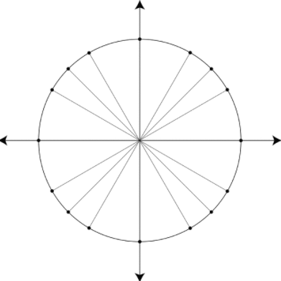

2. Evaluate the SINE of each angle of the unit circle.

3. Evaluate the COSINE of each angle of the unit circle.

4. Evaluate the TANGENT of each angle of the unit circle.

5. Graph the function y = sin(x) on the coordinate plane below. Then give its domain and range.
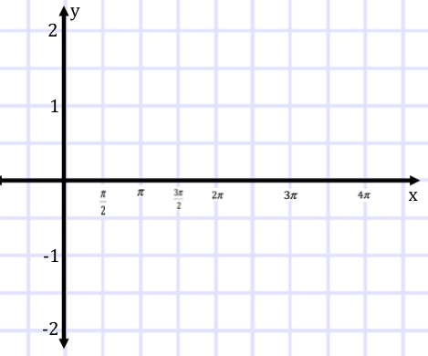

Domain:

Range:

6. Graph the function y = cos(x) on the coordinate plane below. Then give its domain and range.

Domain:

Range:

7. Graph the function y = tan(x) on the coordinate plane below. Then give its domain and range.

Domain:

Range:

