Name: _____________________________

**Problem Set 3.8**

**1 – 10] Match the graphs with the functions.**

**A**

______1.) $f\left(x\right)=4sin(x)$

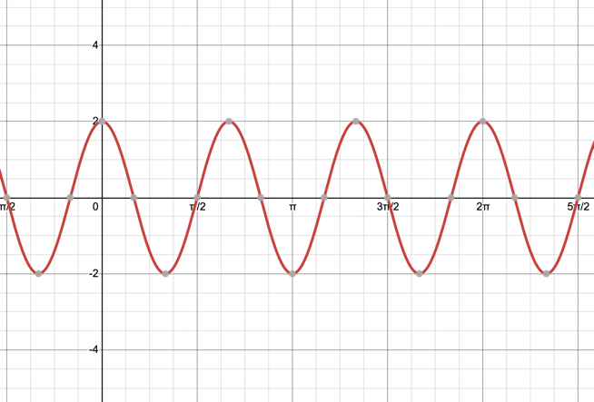

______2.) $f\left(x\right)=4cos(x)$

______3.) $f\left(x\right)=4sin(2x)$

______4.) $f\left(x\right)=4cos(2x)$

______5.) $f\left(x\right)=-2sin(x)$

______6.) $f\left(x\right)=-2cos(3x)$

______7.) $f\left(x\right)=2sin(x+\frac{π}{2})$

**B**

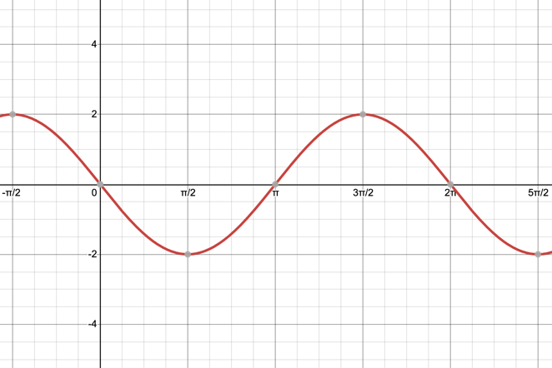

______8.) $f\left(x\right)=2cos(3x)$

______9.) $f\left(x\right)=3sin(2x)$

______10.) $f\left(x\right)=3cos(3x)$

**D**

**C**

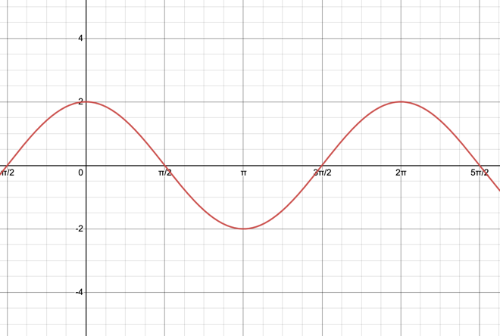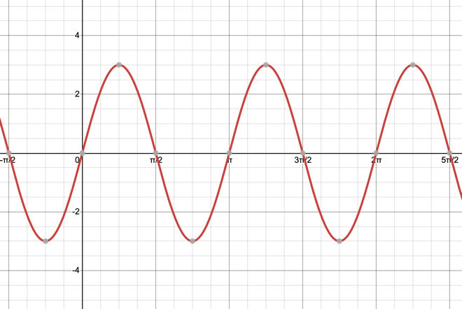

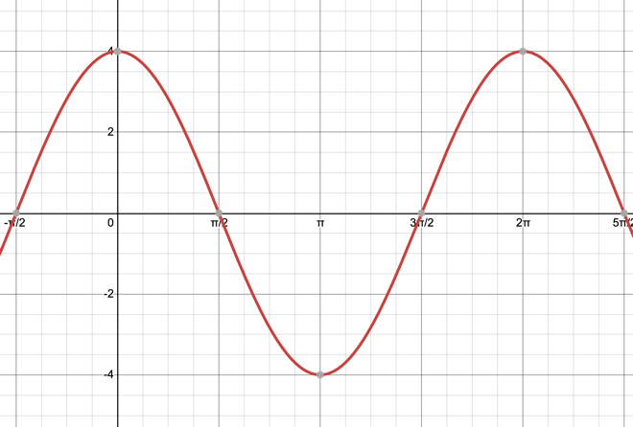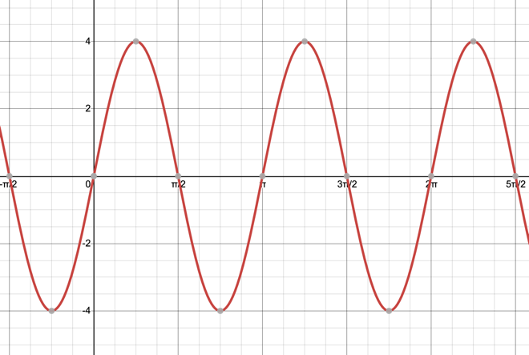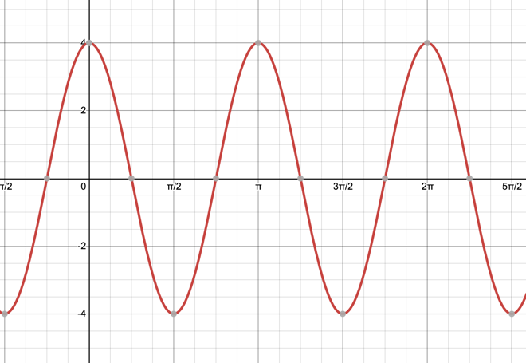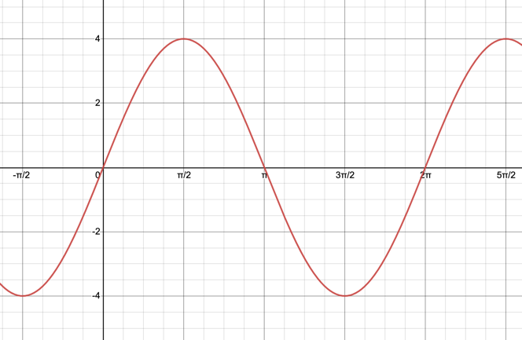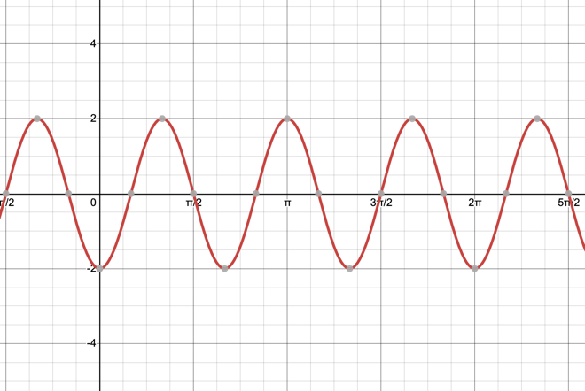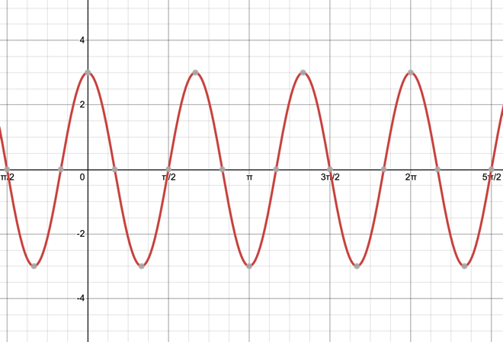

**J**

**I**

**H**

**G**

**F**

**E**

**11.)** What is the amplitude and period of the function $f\left(x\right)=6\sin\left(5x\right)?$

Amplitude: __________________ Period: ___________________

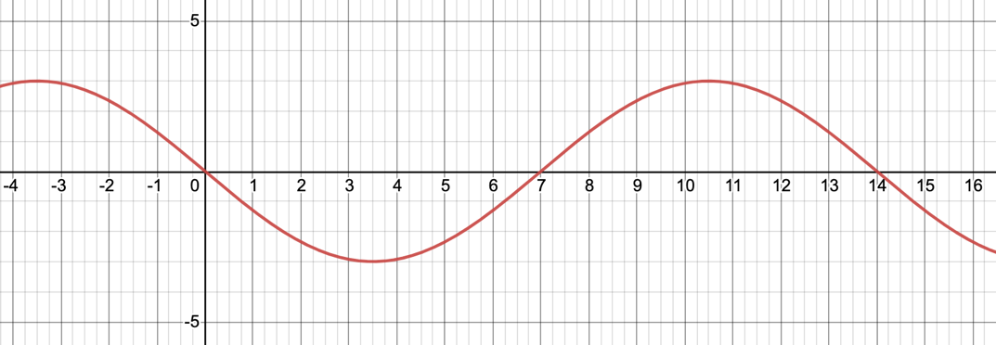**12.)** What is the amplitude and period of the function graphed below? What would be the functions “a” and “b” values?

Amplitude: __________________ Period: ___________________

a: __________________________ b: _______________________

**13.)** List the transformations being done to y = sin(x) to produce the graph of f(x). Would is the domain, range, amplitude, and period of f(x)?

Domain:

Range:

Amplitude:

Period:

$$f\left(x\right)=8\sin\left(x-\frac{π}{2}\right)+1$$

Transformations:

**14.)** List the transformations being done to y = cos(x) to produce the graph of f(x). Would is the domain, range, amplitude, and period of f(x)?

Domain:

Range:

Amplitude:

Period:

$$f\left(x\right)=-\cos\left(4x\right)-12$$

Transformations:

**15.)** List the transformations being done to y = sin(x) to produce the graph of f(x). Would is the domain, range, amplitude, and period of f(x)?

Domain:

Range:

Amplitude:

Period:

$$f\left(x\right)=2.5\sin\left(\frac{π}{6}x\right)$$

Transformations:

**16.)** The function below is a sine function. Write the equation of the graphed function.

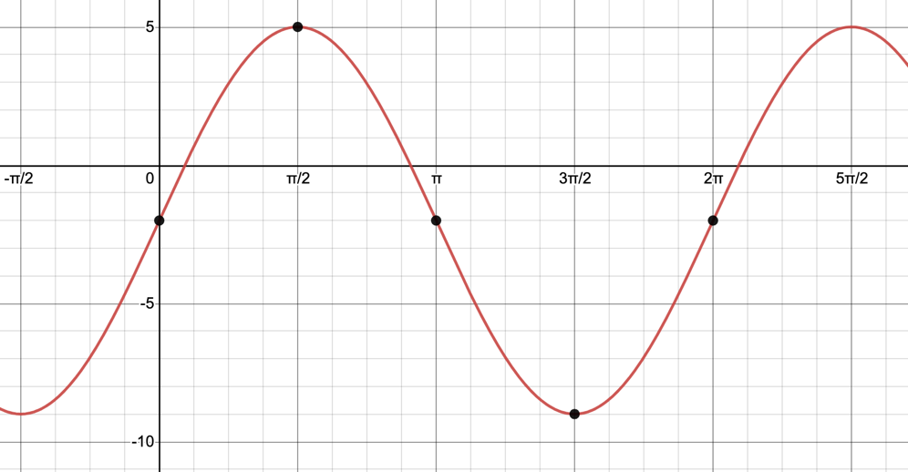

**17.)** Now the function below is a cosine function. Write the equation of the graphed function.

