Problem Set 3.9

1.) Penny is going to ride a ferris wheel and her height is modeled by the graphed function below. Answer the following questions and then write a sine and cosine function that models Penny’s height as a function of time.

- How high is Penny when she gets on the ferris wheel?

- What is her maximum and minimum height? At what time(s) is she at those heights?

- What is the amplitude and period of the wave?

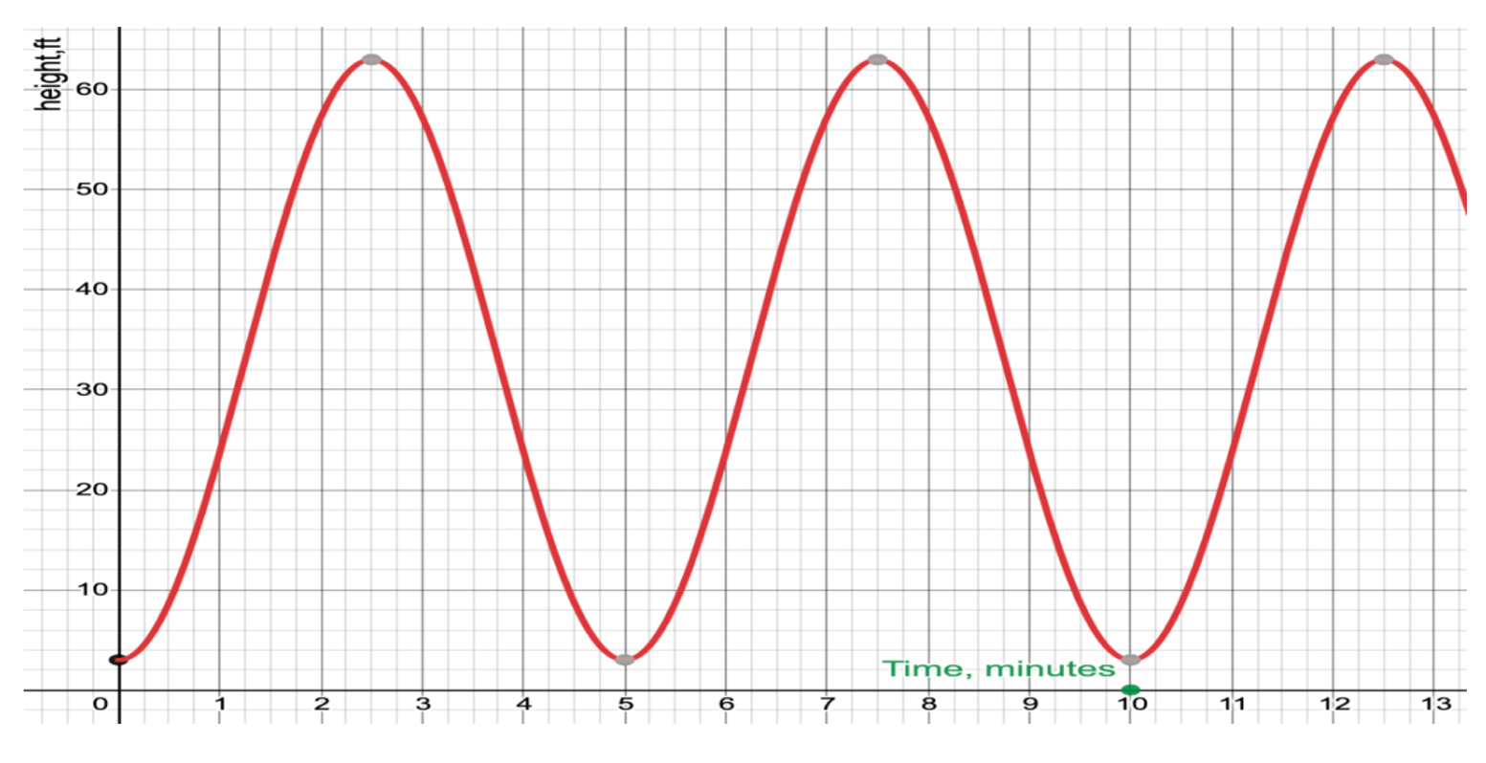

Sine Function: ____________________________ Cosine Function: __________________________

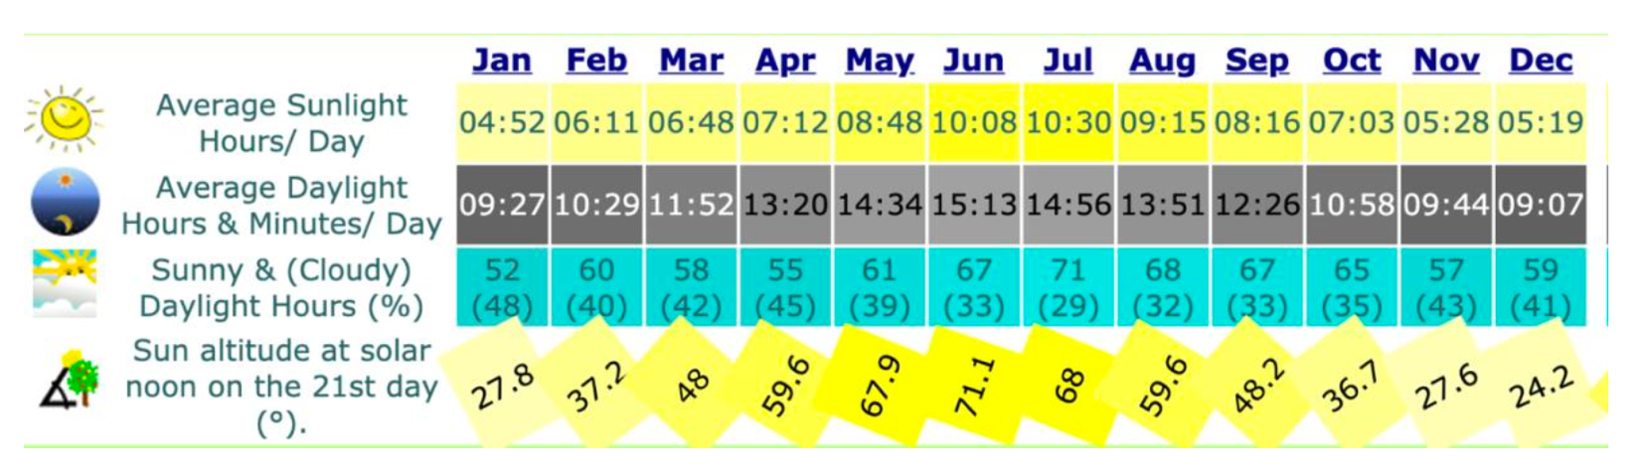
2.) The chart below outlines the total average number of daylight hours in each month in Boston, MA.

Make a scatterplot in desmos for where the independent variable is the month and the dependent variable is the average sunlight hours per day. Let January = 1, February = 2, March = 3, …. December = 12 for your independent variable. Be sure to convert the times into numerical values. For example 4 hours and 52 minutes = 4 + (52/60) hours = 4.87 hours. Then model the motion with a sine and cosine function. Use the questions below to help guide you.

- What is the amplitude and period of the wave?

- What is the vertical shift (midline/equilibrium)?

- Sketch the wave.

Sine Function: ____________________________ Cosine Function: __________________________

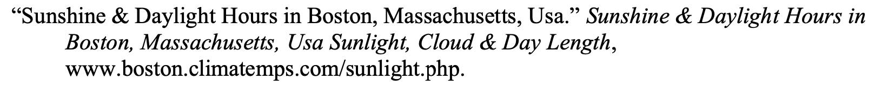
3.) The captain of a shipping vessel must consider the tides when entering a seaport because of the depth of the water can vary greatly from one time of day to another.

Captain Sandy is the captain of the mega yacht, Sirocco from the television program Below Deck Mediterranean. In season 2, the yacht was in Croatia and primarily docked at Hvar Town Port. On any given day, Captain Sandy’s bosun would have to check the tide schedules and report the best times to dock Sirocco based on high tide. Suppose that high tide on a certain day occurs at 5:00 AM when the water is 10.6 meters deep and the next low tide occurs at 11:00 am when the water is 6.5 meters deep.

a) Develop a mathematical model (using a sine or cosine function) that will predict the depth of the water as a function of the elapsed time since midnight.

b) Use your model to suggest at what times the captain could safely enter the seaport if the draft (the minimum depth of water in which the ship or boat can safely navigate) of Sirocco is 9 meters. (Use your Calculator or Desmos)

