FST Name:
PS 4.1 Date: Block:

Problem Set 4.1

1 – 3] For each of the following sequences, describe the sequence in words and then write standard recursive notation.

1) 100, 90, 80, 70, 60, 50, ... 2) 8, 16, 32, 64, 128, 256, ...

3) 10, 100, 10,000, 100,000,000, 10,000,000,000,000,000, ... (10¹, 10², 10⁴, 10⁸, 10¹⁶, …)

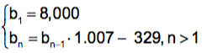
4) Consider the sequence defined by

- Write the first 4 terms of the sequence (rounded to the nearest hundredth).

- What is the 21st term of the sequence?

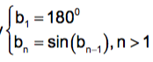
5) Consider the sequence defined by
  - Write the first 4 terms of the sequence.

  - What is the 1,000th term of the sequence?

6) Jo Ann is learning Chinese. Currently she has memorized the meaning of 400 characters. Each month she forgets 10% of the characters she has learned (she remembers 90%) and learns 300 new characters.

  - Write standard recursive notation for the sequence that represents the number of characters she knows each month.

  - If she continues to forget and learn as described above, what is the maximum number of characters she can learn? Explain why.

