FST Name:
PS 4.4 Date: Block:

Problem Set 4.4

1 – 3] Give the recursive and explicit notation for the geometric sequence.

1.)1, -4, 16, -64, … 2.) 4, 24, 144, 864, … 3.) 120, 180, 270, 405, . . .

Recursive: Recursive: Recursive:

Explicit: Explicit: Explicit:

4.) What is the 7th term of the geometric sequence 7, -4.2, 2.52, -1.512, . . . ?

5.) Find the explicit formula for the geometric sequence where a₄ = 500 and the common ratio is 5.

6.) Find the explicit formula for the geometric sequence where a₂ = -40 and a₄ = -10.

7.) Find the explicit formula for the arithmetic sequence where a₃ = 7/4 and a₅ = 7/16.

8.) Given the sequence 7, 7, 7, 7, 7, . . . write both a recursive arithmetic formula for the sequence and a recursive geometric formula for the sequence.

Arithmetic: ______________________________ Geometric: ______________________________

9.) Domestic bees make their honeycomb by starting with a single hexagonal cell, then forming ring after ring of hexagonal cells around the initial cell, as shown. The number of cells in successive rings will form a sequence.
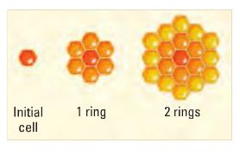

a) Write an explicit formula for the number of cells in the nth ring.

b) What is the total number of cells in the honeycomb after the 9th ring is formed? (Don’t forget to count the initial cell).

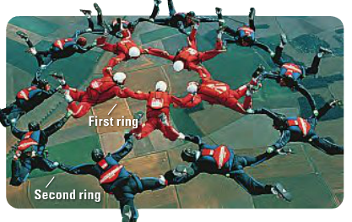
10.) In a skydiving formation with R rings, each ring after the first has twice as many skydivers as the preceding ring. The formation for R = 2 is shown below.

a) Let a_{n} be the number of skydivers in the nth ring.
Find the explicit formula a_{n}.

b) Find the total number of skydivers if there are R = 4 rings.

c) How many rings would there be in a total of 10235 skydivers were in the formation?

