FST Name:
Problem Set 5.1 Date: Block:

Problem Set 5.1

1.) Label the following functions as exponential growth, exponential decay, or neither. List the growth/decay factor and the growth/decay rate.

$a) f\left(x\right)=3{(5)}^{x}$ b) $f\left(x\right)=1.9{(1.07)}^{x}$

$c) f\left(x\right)={15\left(0.9\right)}^{x}$ d) $f\left(x\right)={\left(0.63\right)}^{x}$

$d) f\left(x\right)={\frac{9}{4}\left(2.4\right)}^{x}$ f) $f\left(x\right)={6500\left(1.63\right)}^{x}$

2.) For each description of an exponential function f(x) = a(b)^{x}, find a and b.

a) f(0) = 3 and f(1) = 12 b) f(0) = 4 and f(2) = 1

3.) Make up a context or situation for which the relationship between x and y is y = 300*(1.02)^{x}.

4.) Instead of making a down payment on a house, a couple that lives in an apartment decides to invest $50,000 that they inherited from Aunt Zelda into a real estate fund that earns 6.3% interest annual interest. Write a function that represents the value of the fund, A, after t years have passed.

5.) “Researchers at Cornell’s Lab or Ornithology and Canada’s National Wildlife Research Centre found in a 2019 analysis that wild bird populations in the continental U.S. and Canada have declined by 29% - or a total net loss of around three billion bird – since 1970.”
Jiang, Renee. “Bird Populations Declining Fast across North America.” Emagazine.com, 2 Dec. 2021, https://emagazine.com/bird-population-declines/#:~:text=Researchers%20at%20Cornell's%20Lab%20of,three%20billion%20birds%E2%80%94since%201970.
a) Approximately what was the bird population in 1970?

b) Write a function that gives the total bird population as a function of the number of years that have passed since 1970.

c) What the video at the link 3 Billion Birds Lost. What are some of the reasons listed for the loss in birds?

6.) Put the following expressions in your calculator to evaluate.

a) 10⁻² b) 10⁻¹ c) 10⁰ d) 10¹ e) 10² f) 10³ g) 10⁴

7.) Put the following expressions in your calculator to evaluate.
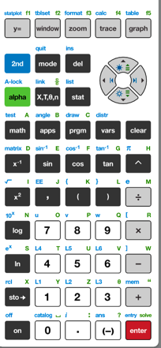

Log key is here!

a) log(0.01) b) log(0.1) c) log(1) d) log(10) e) log(100) f) log(1000) g) log(10,000)

8.) Look at your results from questions 6 and 7. What do you notice?

