FST Name:
PS 5.4 Date: Block:

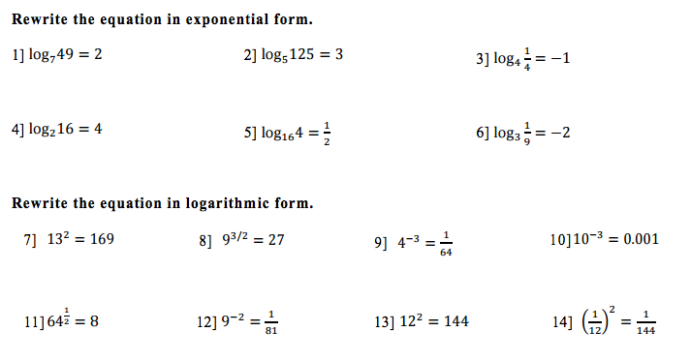
Problem Set 5.4

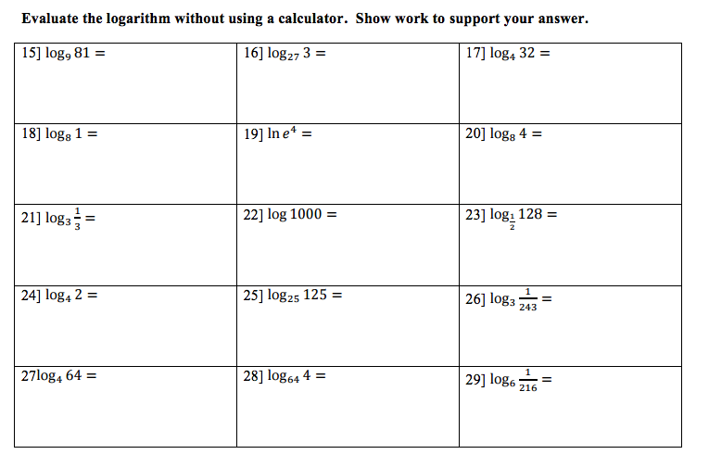

30) Graph the logarithmic functions. List at least 2 points on the graph of f(x). List the domain, range, and asymptotes as they apply.

- f(x) = $\log_{5}x$ b) f(x) = $\log_{3}\left(x+9\right)-5$

31 – 33] Use the definition of the logarithmic function to solve for the value of x.

31. (a) log₅ x = 4 (b) log₁₀ 0.1 = x

32. (a) log₄ 2 = x (b) log₄ x = 2

33. (a) log_{x}1000 = 3 (b) log_{x}25 = 2

34 – 35] Use the Change of Base Formula and a calculator to evaluate the logarithm, correct to six decimal places. Use either natural or common logarithms.

34. log₂5 35. log₅2

