FST Name:
PS 7.3 Date: Block:

Problem Set 7.3

Describe the events by writing I for independent event or D for dependent event.

______ 1. Ann draws a colored toothpick from a jar. Without replacing. It, she draws a second toothpick.
______ 2. John rolls a six on a number cube and then flips a coin that comes up heads.
______ 3. Susie draws a card from a deck of cards and replaces it. She then draws a second card.
______ 4. Seth draws a colored tile from a bag, replaces it; draws a second tile from the bag, replaces it; and then draws a tile a third time from the bag.
______ 5. You draw a red marble from a bag, then another red marble (without replacing the first marble).
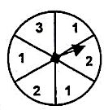
Using the two spinners, find each compound probability.

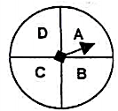
6. P(A and 2) = _______________ 7. P(D and 1) = _______________

8. P(B and 3) = _______________ 9. P(A and not 2) = ________________

A box contains 3 red marbles, 6 blue marbles, and 1 white marble. The marbles are selected at random, one at a time, and are NOT replaced. Find each compound probability.

10. P(blue and red) = _____________________ 11. P(blue and blue) = _________________________

12. P(red and white and blue) = _______________________ 13. P(red and red and red) = ____________________

14. P(white and red and white) = ______________________ 15. P(not white) = _________________

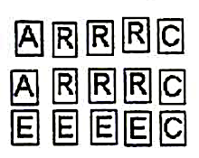
Suppose that two tiles are drawn from the collection shown at the right. The first tile is replaced before the second is drawn. Find each compound probability.

16. P(A and A) = _________________ 17. P(A and not R) = __________________

Suppose that two tiles are drawn from the same collection shown above. The first tile is NOT
Replaced before the second is drawn. Find each compound probability.

18. P(A and A) = ________________ 19. P(A and not R) = __________________

20. A basket contains five apples and seven peaches. You randomly select one piece of fruit and eat it. Then you randomly select another piece of fruit. Find the probability the first piece of fruit is an apple and the second piece of fruit is a peach.

21. There are eight shirts in your closet, four blue and four green. You randomly select one to wear on Monday and then toss it in the laundry basket to wash when you are done. You then pick a different one to wear on Tuesday. What is the probability you wear a blue shirt both days?

22. A penny and a nickel are tossed. Find the probability that the penny shows head, given that the nickel shows head.

23. Two hundred patients who had either hip surgery or knee surgery were asked whether they were satisfied or dissatisfied regarding the result of their surgery. The following table summarizes their response.
Complete the two-way frequency table.
Surgery | Satisfied | Dissatisfied | Total
Knee | 70
Hip |  | 15 | 105
Total | 160 |  | 200

a) If one person from the 200 patients is selected at random, determine the probability that the parson was satisfied given that the person had knee surgery.

b) P(satisfied) = b) P(knee and dissatisfied) = c) P(hip or dissatisfied) =

d) P(dissatisfied | hip surgery) = e) P(knee | satisfied) =

24. A number selected, at random, from the set {1, 2, 3, 4, 5, 6, 7, 8}. Find…
a) P(odd) = b) P(prime | odd) =

25. The senior class is 55% female, and 32% are females who play a competitive sport. Find the probability that a student plays a competitive sport, given that the student is female.

26. A utility research company asked 50 of its customers whether they pay their bills online or by mail. What is the probability that a customer pays online given that the customer is male?

27. Use the table below to find the probability for a randomly selected employee:

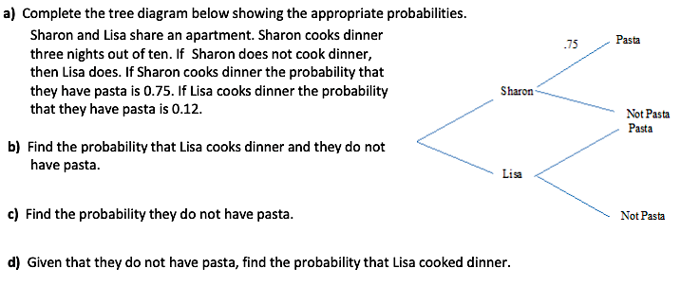
28)

