TASK 3: Tide Schedules

Assignment:
Step 1:
Choose a specific harbor/port/city and research the tide schedule. Research the high and low tides for that place over the course of at least 2 complete days (48 hours - should have about 4 cycles).

For example - tide schedules for Charleston, SC can be found at the website below.
https://www.usharbors.com/harbor/south-carolina/charleston-sc/tides/

Be sure to gather all of the information you need to complete a full MLA citation for where you got the information you used. This will need to be included on your final product.

Step 2:
Once you have gathered the high and low tide times over the course of at least two complete days (48 hours) you will have 8 data points available where the x-value represents time and the y-value represents the height of the water. Sketch the scatter plot of the height of the water (y axis) at each time (x - axis) of the high and low tides. Desmos is a great tool for you to use. When you go to the graphing tool you can select + in the upper left corner and then table to type in your data values (picture below). Note that you will need to determine a suitable scale for the x-axis. Usually, the x-axis is set to represent the total number of hours past midnight on a specific date.

Step 3: 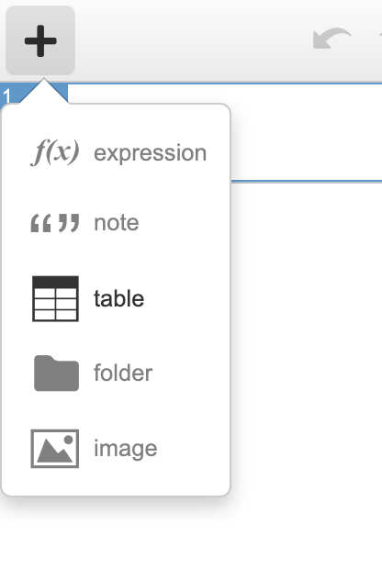
Determine the amplitude and period of the scatter plot you graphed in step 2. Once you determine the amplitude and period, then determine the “a” and “b” value of your sine/cosine function.

Amplitude: _____________ Period: _____________

a: _____________ b: _____________

Step 4:
Create a sine and cosine function that models your scatter plot from Step 2. Use the information you’ve outlined in Step 3 to help create your functions. Graph your sine and cosine function in conjunction with the scatterplot to ensure they closely match!

Sine Function: ___________________

Cosine Function: ___________________

Step 5:
Create your final product that you will turn in.

Assessment Product (what you turn in)

You will hand in a virtual poster (one page) that showcases the information about the tide schedules of at least two full days of the place you researched. Your virtual poster must include the following information:
- At least 8 data points that represent at least 2 days (24 hours) of tide heights (Citation for where you got your data)
- Scatterplot of the data points solely
- Amplitude and Period of the waves
- Sine Model for the plotted tide
- Cosine Model for the plotted tide
- Graph of the Sine Model with the scatterplot
- Graph of the Cosine Model with the scatterplot

Your virtual poster should clearly show the information above. It should be aesthetically pleasing and creative. Canva.com has many good templates and there are many other great resources for you to use. The final poster should be submitted as a PDF. The scoring rubric for this project is available here.

