Transformations of Functions Name:
Desmos Activity Date: Block:

Transformations of Functions

These notes are to be completed in conjunction with a Desmos Activity. Please sign into the Desmos Activity as instructed by your teacher to get started!

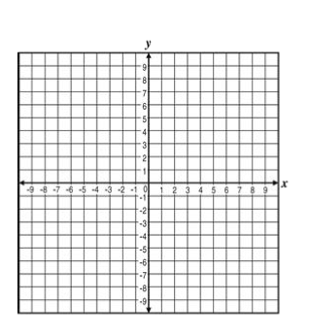
Slide 1: Graph the parent function for $y=\sqrt{x}$ on the coordinate plane below. We will be using this function to explore transformations of functions. List the parent points of the function by filling in the table of values.

x | y

Slide 2: What do you notice about what a, h, and k do to the graph of the parent function? List your observations in the space provided.

a
h
k

Slide 3: When you move the “a” slider to 2, 4, 7, and 1/2 you have now graphed the functions below respectively. Describe what happens to the parent function when you changed the “a” slider. Be specific about what changed within the points. Then graph the functions below and fill in the table of values. Label all of your points.
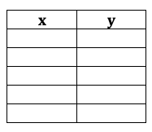
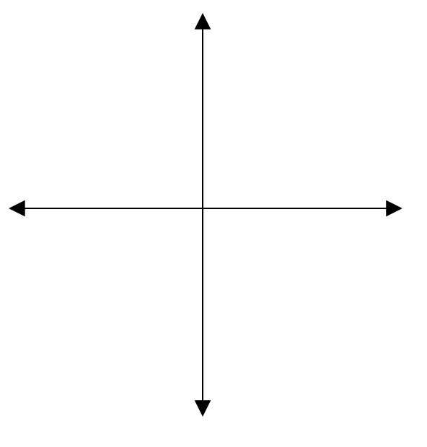
$f\left(x\right)=2\sqrt{x}$ $f\left(x\right)=4\sqrt{x}$ $f\left(x\right)=7\sqrt{x}$ $f\left(x\right)=\frac{1}{2}\sqrt{x}$
Slide 4: Summarize what you’ve learned about “a” in your own words in the box to the left.
Transformation Rule # 1

When “a” changes the function ……

Practice 1: The graph of a parent function f(x) is given on the left. Sketch the graph of the designated functions on the provided space and label all of your points.
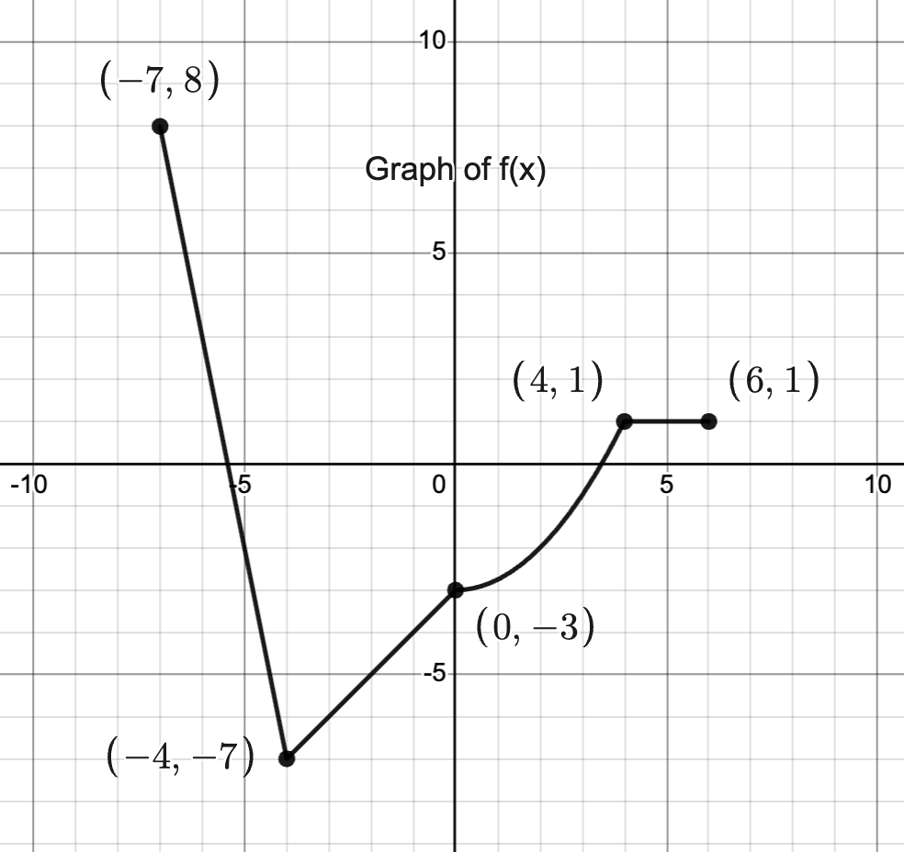
Graph y = $3f(x)$ Graph y = $\frac{1}{2}f(x)$

Slide 5: When you move the “h” slider to 4 and then -6 you have now graphed the functions below respectively. Describe what happens to the parent function when you changed the “h” slider. Be specific about what changed within the points. Then graph the functions below and fill in the chart.
$f\left(x\right)=\sqrt{x-4}$ $f\left(x\right)=\sqrt{x+6}$
Slide 6: Summarize what you’ve learned about “h” in your own words.

Transformation Rule # 2

When “h” changes the function ……

Practice 2: The graph of a parent function f(x) is given on the left. Sketch the graph of the designated functions on the provided space and label all of your points.
Graph y = $f(x-2)$ Graph y = $f(x+8)$

Slide 7: When you move the “k” slider to 5 and then -3 you have now graphed the functions below respectively. Describe what happens to the parent function when you changed the “k” slider. Be specific about what changed within the points. Then graph the functions below.
$f\left(x\right)=\sqrt{x}+5$ $f\left(x\right)=\sqrt{x}-3$

Slide 8: Summarize what you’ve learned about “k” in your own words.

Transformation Rule # 3

When “k” changes the function ……

Practice 3: The graph of a parent function f(x) is given on the left. Sketch the graph of the designated functions on the provided space and label all of your points.
Graph y = $f\left(x\right)+5$ Graph y = $f\left(x\right)-9$

Slide 9: Card Sort! Match the function with the transformations. Your instructor can check your answers before you write anything so ask them to check when you’re ready. Then transfer the correct matches onto your paper once you have everything correct.

 | Match 1 | Match 2 | Match 3 | Match 4 | Match 5
Function
Transformations

Slide 10: Graphing on your own!
Write down the transformations you expect from each function and then apply them to the parent function $f\left(x\right)=\sqrt{x}$. Use a chart if you prefer! Once you have finished graphing, turn on the function in Desmos and see if you were correct. If not, analyze your mistake and correct your answer.

$f\left(x\right)=3\sqrt{x+6}$ $f\left(x\right)=\sqrt{x-4}-7$ $f\left(x\right)=\frac{1}{2}\sqrt{x}+5$
Transformation: Transformations: Transformations:

Practice 4: The graph of a parent function f(x) is given on the left. Sketch the graph of the designated functions on the provided space and label all of your points.
Graph y = 2$f\left(x\right)+4$ Graph y = $f\left(x-4\right)-3$
Slide 11: What happens to the square root function when the negative is added to the front? Investigate by clicking on the second function (blue). How would you describe the transformation?

Slide 12: What happens to the square root function when the negative is added inside of the function? Investigate by clicking on the second function (blue). How would you describe the transformation?

Slide 13: Summarize what you learned about negatives in your own words.

Transformation Rule # 4

When a negative is applied to the front of the function….

When a negative is applied to the inside of a function…

Slide 14: Card Sort!

Slide 14: Card Sort! Match the cards in pairs and then have your instructor check when you are finished.

Practice 5: The graph of a parent function f(x) is given on the left. Sketch the graph of the designated functions on the provided space and label all of your points.
Graph y = -$f\left(x\right)$ Graph y = $f\left(-x\right)$

Slide 15: How does the graph change as the value of b changes? Turn on the slider and investigate. Does it remind you of any transformation you have already seen? List your observations in the provided space.

Slide 16: When you move the “b” slider to 2, 3, and 0.5 you have now graphed the functions below respectively. Describe what happens to the parent function when you changed the “b” slider. Be specific about what changed within the points (look at the x values). Then graph the functions below.
$f\left(x\right)=\sqrt{2x}$ $f\left(x\right)=\sqrt{3x}$ $f\left(x\right)=\sqrt{\frac{1}{2}x}$

Slide 17: Summarize what you learned about b in your own words.

Transformation Rule # 5

When “b” changes the function ……

Final Summary:

Transformations of Function Rules

If f(x) is a function, then

$$y=af\left(b\left(x-h\right)\right)+k$$

