Warm Up

The chart below outlines the earnings of full-time year-round workers aged 25 – 34 years old in the US from 1995 to 2018 (selected years). Use CODAP to create a model analyzing the year as the independent variable and earnings of those individuals who hold a Bachelor’s degree as the dependent variable. The analyze the data.

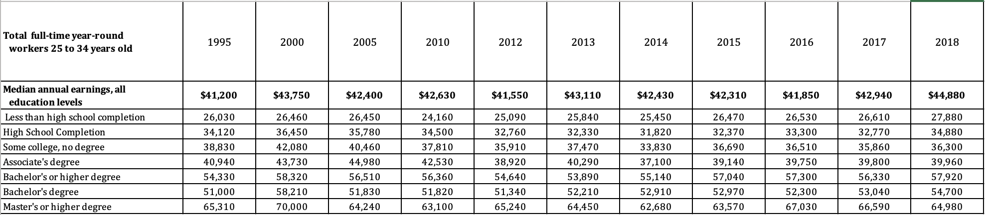

Analyze the Data.

According to your model, in what year was the earnings for someone with a Bachelor’s degree $45,000?

According to your model, what will the earnings for someone with a Bachelor’s degree be in 2022?

